Order:

English name

Nepali name

Scientific name

Family name

Physical features

Importance

Fun fact

Holy Basil

Tulasi

# Ocimum tenuiflorum

Lamiacaea/Mints

**Physical features:**

(Herb)

Holy Basil has aromatic leaves that are oval or lance-shaped, with serrated edges. This plant has slender and branching stems that can grow up to a meter (3 feet) in height. Likewise, Holy Basil produces small, tubular flowers in various colors, including white, pink or purple. The flowers are arranged in dense clusters on upright spikes. Holy Basil also has a well-developed root system with fibrous roots that anchor the plant in the soil and absorb water and nutrients.

**Importance**

1. It is used in aiding cough, asthma, cold and other respiratory diseases etc.
2. It is rich in Vitamin C and zinc thus, it acts as a natural immunity booster.
3. It has anti-bacterial and anti-viral properties which help to fight infections and reduce fever.
4. Dried leaves of this plant are mixed with stored grains to repel insects.

**Fun fact:**

Holy Basil is considered as a sacred plant in Hinduism and is revered for its spiritual and medicinal properties. It is very commonly found in South-East Asian households, temples and gardens. In addition to its cultural significance, Holy Basil has a unique fragrance that is often described as a combination of cloves, peppermint and lemon.

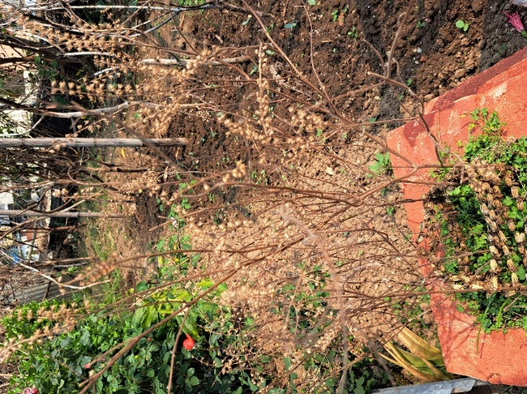

Zonal Geranium

Zonal Geranium

# Pelargonium

Geraniaceae

**Physical features:**

(Perennial shrub)

Zonal geraniums have large, rounded or lobed leaves that are typically dark green in color. Likewise, these plants produce clusters of showy, symmetrical flowers in a wide range of colors. The flowers can be single or double and they come in shades of red, pink, white, salmon, and other vibrant hues. The stems of these plants are typically upright and slightly woody. Similarly, Zonal geraniums have fibrous roots and scented leaves, which can release pleasant aromas when touched or brushed against.

**Importance:**

1. Zonal geraniums are cultivated as ornamental plants due to their vibrant flowers and attractive foliage.
2. These plants have aromatic leaves that can be crushed to release a pleasant fragrance.
3. Although, this plant is mostly used for ornamental purposes, it is also used in traditional medicine for the treatment of respiratory infections and cold symptoms.
4. Zonal geraniums are well-suited for container gardening. They can be grown in pots, hanging baskets or window boxes adding beauty to balconies and indoor spaces.

**Facts:**

Zonal geraniums have the ability to emit a pleasant scent when their leaves are touched or brushed. This scent is often described as a combination of various aromas, including rose, lemon, citrus or even hints of mint.

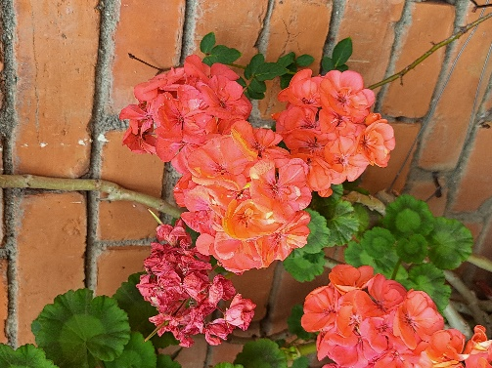

Welsh Onion

Pyaj

# Allium fistulosum

Armyllidaceae

**Physical features:**

(herb)

The leaves of Welsh onions long, tubular and hollow. They are dark green in color and have a smooth texture. These plants also have small, elongated bulbs that grow underground. The bulbs are white in color, have a mild onion flavor and are edible. Similarly, Welsh onions have a fibrous root system that helps anchor the plant in the soil and absorb nutrients and water. Likewise, the stalks of these plants can reach a height of 60-90 centimeters(24-36 inches).

**Importance:**

1. Welsh onions are widely used in various cuisines around the world. The green leaves and white bulbs of it add a fresh and distinctive taste to food. They are commonly used in garnish, salads, stir-fries, soups and many other dishes.
2. Welsh onions are a nutritious addition to meals. They are low in calories but rich in Vitamin C, Vitamin K, folate and potassium. Consuming it can contribute to a well-rounded and healthy diet.
3. Welsh onions contain beneficial compounds that possess potential medicinal properties. They have antioxidant, antimicrobial and anti-inflammatory effects, contributing to overall health and well-being.

**Fun fact:**

The name “Welsh onion” can be a bit misleading as it does not have a direct connection to Wales. The term “Welsh” is believed to have derived from German word “Welsch” which means “foreign” or “non-native.” It was used to describe plants that were brought to Europe from other regions. 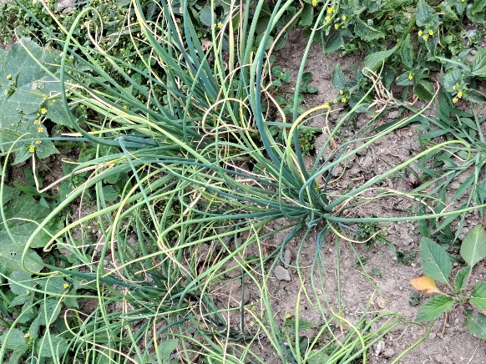

Umbrella Palm

_________

# Cyperus alternifolius

Cyperaceae

**Physical features:**

(herb)

The leaves of Umbrella Palm are long, slender and grass-like which grow in an umbrella-like arrangement at the top of its stem. The stem of this plant is slender, erect and cylindrical. Similarly, Umbrella Palm produces small flowers which are usually brown or green in color. Likewise, Umbrella Palm has rhizomes, which are underground stems that help the plant propagate and spread.

**Importance:**

1. Umbrella Palm is highly valued as an ornamental plant due to its unique and attractive appearance.
2. It is effective in filtration and purification of water. It has the ability to absorb excess nutrients, pollutants and toxins from water bodies, thereby improving water quality
3. The dense root system of Umbrella Palm helps in stabilizing soil and prevent erosion, particularly in areas prone to erosion along water bodies and shorelines.

The Umbrella Palm is not actually a palm tree despite its name. It belongs to the Sedge family (Cyperaceae) and is commonly referred to as a palm due to its palm-like appearance with umbrella like arrangement.

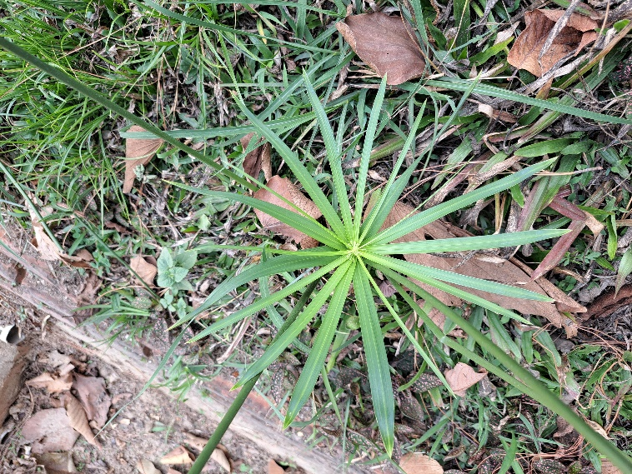

Topped Lavender

___________

# Lavandula stoechas

Lamiaceae

Herb

Topped Lavender is a perennial herb that typically grows to a height of 12 to 24 inches. The leaves of Topped Lavender are narrow, elongated and ranging in color from grayish-green to green. The flowers of Tapped Lavender are arranged in dense clusters at the top of long stalks, forming a showy and colorful bloom. Similarly, Topped Lavender emits a pleasant and aromatic scent, which is often described as sweet, floral and herbaceous.

1. Topped Lavender is highly valued as an ornamental plant due to its attractive appearance and vibrant flowers. It adds beauty, texture and a delightful fragrance to outdoor and indoor spaces.
2. In traditional herbal medicine, topped lavender has been used for various purposes. It is believed to have antiseptic, anti-inflammatory and antispasmodic properties.
3. The flowers of topped lavender, along with the tops are used as culinary herbs. They are infused in cooking oils, incorporated into desserts, added to beverages or used as a garnish.

Topped lavender (Lavandula stoechas) is sometimes referred to as "Spanish lavender" due to its origin in the Mediterranean region, particularly Spain and Portugal. However, it is interesting to note that topped lavender is not exclusive to Spain, and it can also be found growing in various other countries with suitable climates around the world. So, despite the name, topped lavender has a global presence beyond Spain.

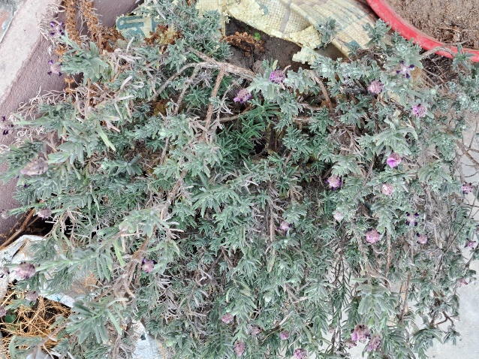

Mugwort

Titepati

# Artemisia vulgaris

Asteraceae

(Herb)

Mugwort is a perennial herbaceous plant that typically grows to a height of 60 to 150 centimeters. It has an erect and bushy growth habit. Similarly, the leaves of Mugwort are alternate, deeply lobed, and fern-like in appearance and are dark green on the upper surface and lighter underneath. Likewise, Mugwort has a sturdy and rigid stem that is grooved and often reddish or purplish in color. It also has a creeping rhizomatous root system, which allows it to spread and form dense colonies over time.

1. Mugwort leaves have been used in certain culinary traditions, particularly in East Asian cuisines. They can be added to dishes as flavoring agents or used for wrapping foods before cooking.
2. The strong aroma of mugwort has been found to repel certain insects, including mosquitoes and moths. Some people use dried mugwort leaves as natural insect repellents or incorporate them into homemade repellent formulations.
3. It is believed to have various health benefits, such as promoting digestion, relieving menstrual discomfort, and aiding in relaxation.

Mugwort is known for its connection to dreams and vivid experiences. In some cultures, Mugwort is believed to enhance dreaming and increase the intensity of dreams. It has been used historically as a dream herb, with people placing Mugwort under their pillows or using it in herbal pillows to promote more vivid and lucid dreams. Mugwort's association with dreams has made it a subject of interest in folklore, literature, and mystical practices throughout history.

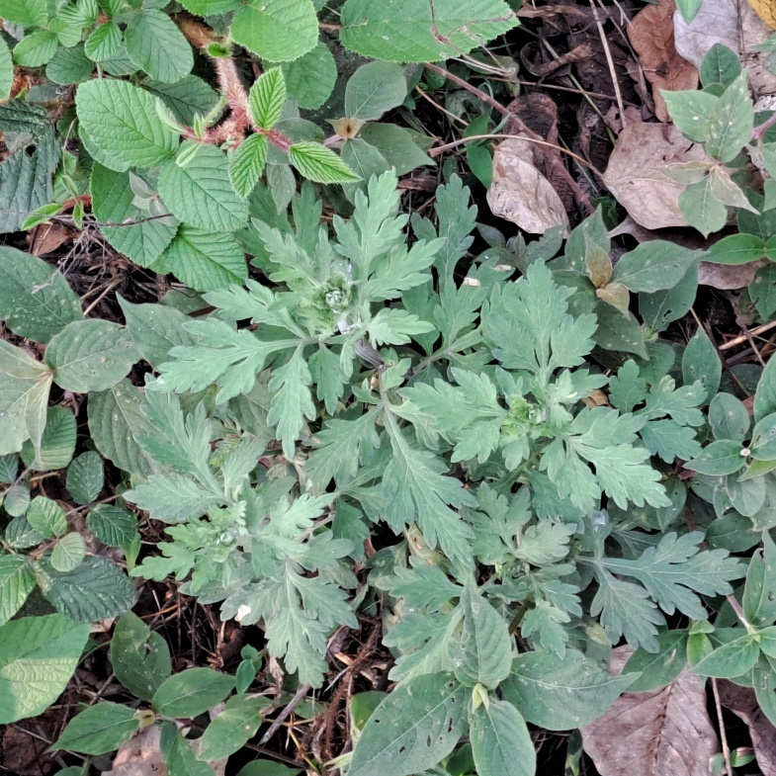

Thimble Cactus

Madhyakalin Cactus

# Mammillaria gracilis

Cactaceae

(Herb)

Thimble cacti are small to medium-sized cacti, typically growing up to 10-15 centimeters in height and 6-8 centimeters in diameter. The surface of the thimble cactus is covered in closely spaced tubercles. These tubercles are cone-shaped or cylindrical and arranged in a spiral pattern around the stem. Similarly, Thimble cacti have a dense covering of spines on their tubercles. The spines are usually straight, needle-like, and vary in color from white to yellow or brown. Likewise, Thimble cacti produce small, bell-shaped flowers that emerge from the space between the tubercles.

1. Thimble cactus is highly valued for its ornamental appeal. Its compact size, attractive tubercles, and spines make it a popular choice for cactus collectors and enthusiasts.
2. Thimble cactus is often used in educational settings for learning about cacti and desert ecosystems.
3. Thimble cacti, like other cacti, play a role in their native ecosystems. They provide habitat and food sources for various small animals, insects, and birds.

Thimble cactus is known for its ability to produce beautiful flowers that open for a very short duration. The flowers typically bloom for only a day or two, usually in the morning, and then close by the evening.

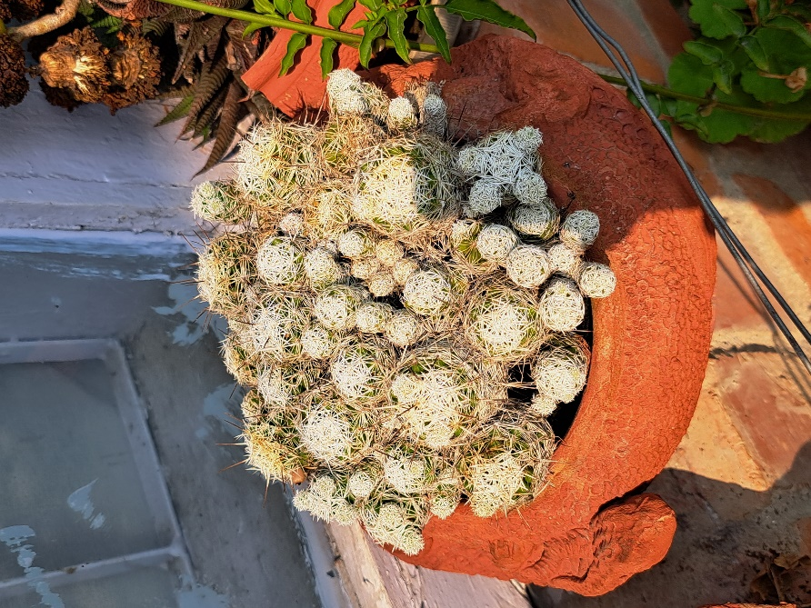

Malabar leaf

Tejpatta

# Cinnamomum tamala

Lauraceae

(Tree)

Malabar leaf comes from a medium-sized evergreen tree. It can grow up to 15 to 20 meters in height, with a trunk diameter of about 40 to 60 centimeters. Malabar leaf has a strong and aromatic fragrance. When crushed or dried, the leaves emit a pleasant, spicy aroma. Similarly, the upper surface of the leaves of Malabar Leaf is glossy and dark green, while the underside is lighter in color. The leaves are typically 5 to 12 centimeters long and 2 to 4 centimeters wide.

1. Malabar leaf is a widely used spice in Indian cuisine, especially in dishes from the southern regions. It is known for its strong, aromatic flavor that adds depth and richness to curries, stews and other savory dishes.
2. Malabar leaf has been used in traditional medicine systems for its potential health benefits. It is believed to have antibacterial, anti-inflammatory, and digestive properties.
3. The strong and pleasant fragrance of Malabar leaf makes it useful in aromatherapy and perfumery.
4. In some cultures, Malabar leaf holds cultural and ritual significance. It is used in religious ceremonies, festivals, and as an offering to deities.

FUN FACT:______

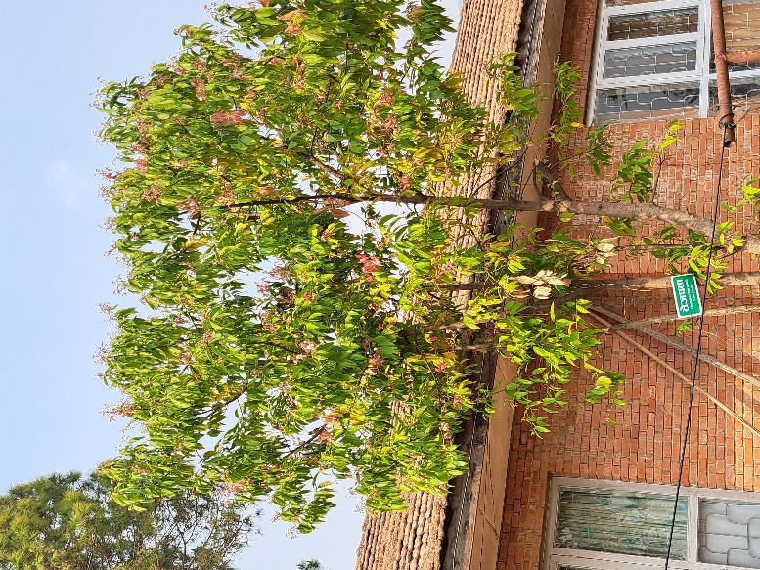

Tea Rose

Chiya Gulab

# Rosa odorata

Rosaceae

(Shrub)

Tea roses are known for their large, showy flowers that come in various colors, including shades of pink, red, white, and yellow. The flowers are typically double or semi-double, with multiple layers of petals. The tea rose is a woody shrub with thorny stems. Similarly, the stems are covered in small, sharp thorns or prickles. Likewise, the leaves of the tea rose are typically dark green and glossy and are composed of multiple leaflets arranged along a central stem.

1. Tea roses are widely cultivated and appreciated for their ornamental beauty. Their large, fragrant flowers and variety of colors make them popular choices for gardens and floral arrangements.
2. Tea roses are known for their delightful fragrance. The essential oils extracted from tea roses are used in the production of perfumes, soaps, and other cosmetics.
3. Roses, including tea roses, have long held symbolic meanings in various cultures. They are often associated with love, beauty, and romance. Tea roses are commonly used in weddings, anniversaries, and other special occasions as symbols of affection and celebration.

The first man on Earth was Adam according to Christianity and the first Tea Rose was named after him. Tea rose or Adam was given a unique and separate botanical name. It was Tea Scented China Rose with the scent of a newly opened choicest tea from China. As time passed by, the name was shortened into Tea Rose.

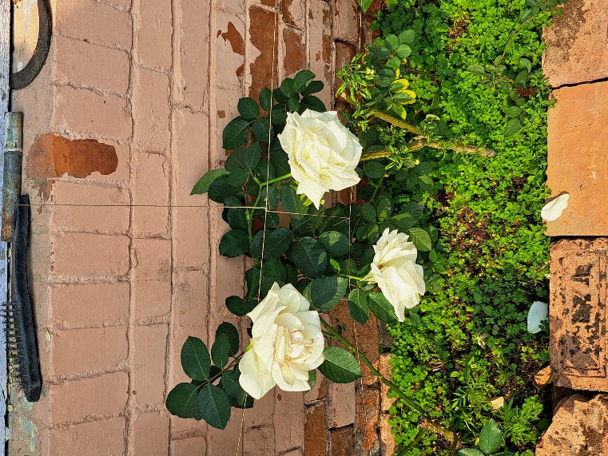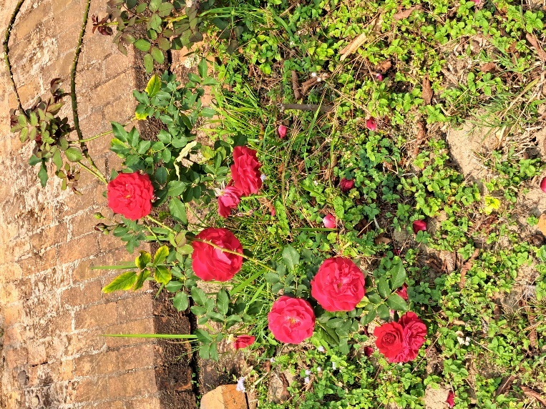

Swiss Cheese Plant

Swiss Cheese Plant

# Monstera deliciosa

Araceae

(Evergreen tropical vines and shrubs)

The leaves of the Swiss cheese plant are large, glossy, and heart-shaped when young. As they mature, they develop distinct splits and holes, giving them a unique and characteristic appearance resembling Swiss cheese. Similarly, the stems of the Swiss cheese plant are thick, green, and aerial. Likewise, the Swiss cheese plant produces long, aerial roots that grow from the stems. In its natural habitat, the Swiss cheese plant can grow quite large, with leaves reaching up to 60 cm in length.

1. The Swiss cheese plant is widely cultivated as an ornamental plant due to its unique physical appearance. The large leaves with splits and holes make it a popular choice for indoor gardens, offices, and tropical-themed landscapes.
2. Like many other houseplants, the Swiss cheese plant contributes to improving indoor air quality by filtering and purifying the air.
3. The presence of plants, including the Swiss cheese plant, has been shown to have positive effects on human well-being. Being around nature and greenery can reduce stress, enhance mood, and improve productivity.

The natural splits and holes in the leaves of the Swiss cheese plant serve a purpose beyond aesthetics. In their native rainforest habitat, these fenestrations allow sunlight to pass through the dense canopy, enabling the plant to thrive on the forest floor. The holes in the leaves help to reduce wind resistance, allowing the leaves to withstand strong winds without getting damaged.

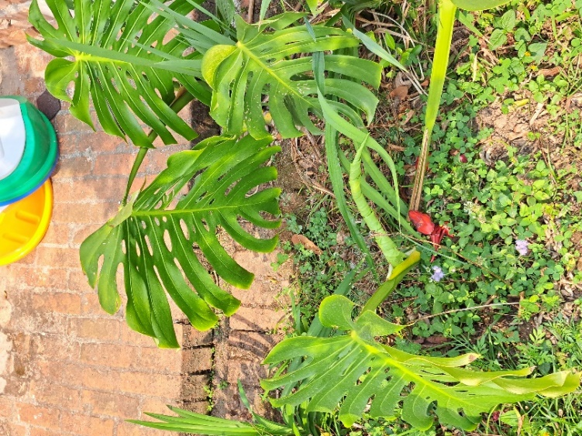

Snake Plant

Sarpindra

# Sansevieria trifasciata

Asparagaceae

(Perennial Herb)

Snake plants can vary in size, ranging from small, compact varieties to larger specimens. On average, the leaves can grow between 60 to 120 centimeters in height. The leaves of a snake plant are long, upright and are generally dark green with light green or gray-green horizontal striping. Similarly, Snake plants have rhizomes (underground stems), from which roots and new shoots emerge. While snake plants can produce flowers, it is not common for them to bloom when grown indoors. The flowers are typically small and appear on long stalks rising from the center of the plant.

1. Snake plants are known for their ability to improve indoor air quality. They absorb these harmful substances and release oxygen, making them excellent natural air purifiers.
2. Snake plants are also cultivated for their ornamental properties. They have attractive leaves with various patterns and colors, making them visually appealing as houseplants.
3. Snake plants also have additional health benefits, such as improving sleep quality by releasing oxygen at night and reducing headaches, eye irritation, and respiratory symptoms associated with indoor air pollution.

Snake plants are not only known for their air-purifying properties but also for their ability to release oxygen at night. Most plants release oxygen during the day through photosynthesis, but snake plants perform a type of photosynthesis called crassulacean acid metabolism. This adaptation allows them to store carbon dioxide during the day and release oxygen at night, making them ideal bedroom companions as they continue to emit oxygen even when you sleep. This unique behavior earned them the nickname "bedroom plant" or "oxygen plant."

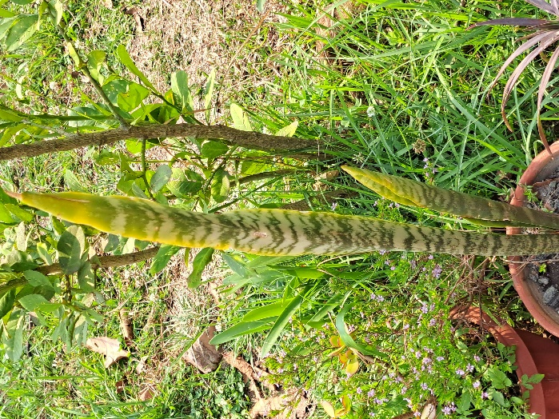

Sal Tree

Sal

# Shorea robusta

Dipterocarpaceae

(Tree)

Sal trees are large and can reach heights of up to 35-40 meters or even taller. Its trunk is straight and cylindrical and can have a diameter of up to 2-3 meters or more. Similarly, the leaves are simple, alternate, and spirally arranged. They are large, leathery, with a shiny dark green upper surface and a lighter green lower surface. Likewise, the wood of the Sal tree is highly valued for its strength and durability. It is reddish-brown in color and has excellent timber qualities.

1. Sal wood is commonly used in construction, furniture making, flooring, etc. The timber is known for its excellent quality and is an important economic resource.
2. Some parts of the Sal tree including the bark, leaves, and resin, have been used in traditional medicines. They are believed to have anti-inflammatory, antimicrobial, and antiseptic properties.
3. The widely spread root system of Sal trees helps in preventing soil erosion and stabilizing slopes mainly in Hilly and forested regions.

Sal trees are known for their ability to produce a natural resin called "Salai guggal". This resin has unique properties, including the ability to emit a pleasant fragrance when burned. It is often used as incense in religious ceremonies and rituals.

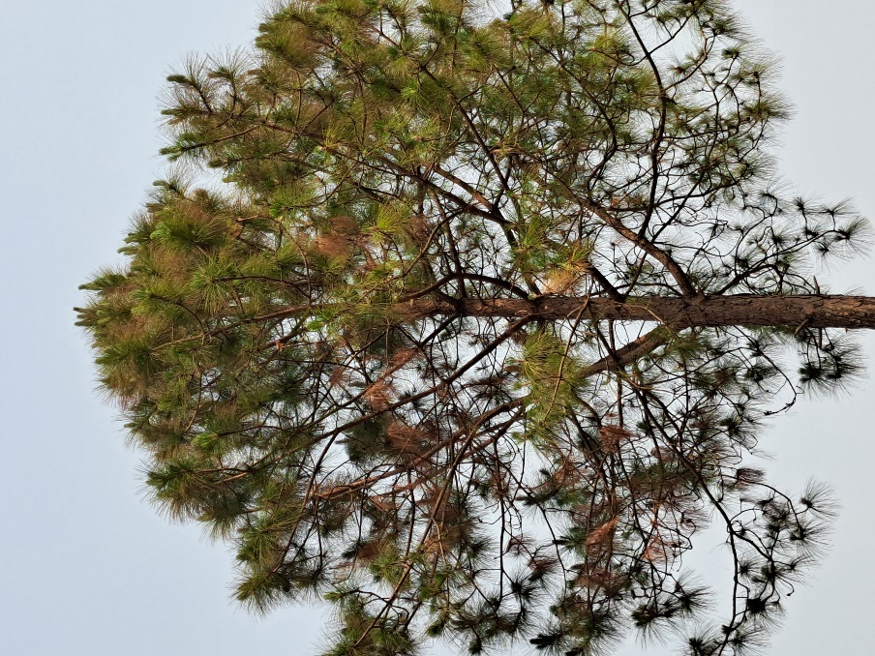

Stinging Nettle

Sisnu

# Urtica dioica

Urticaceae

(Herb)

The leaves of Stinging Nettle heart-shaped and are covered with tiny, hollow stinging hairs that can cause a stinging sensation upon contact. They have a dark green color and a rough texture. Likewise, the stems of Stinging Nettle are erect and are covered with stinging hairs similar to the leaves. The stems can grow up to several feet in height. Stinging Nettle has a fibrous root system structure that spreads horizontally underground. The roots are yellowish in color.

1. Stinging Nettle is used in traditional medicine. It is believed to have anti-inflammatory, antioxidant, and anti-allergic properties.
2. Stinging Nettle is highly nutritious and is a good source of vitamin A, C and K and some minerals such as iron, calcium, and magnesium.
3. Stinging Nettle leaves are known for their unique flavor and are valued for their culinary versatility.

When the leaves are cooked or dried, the stinging hairs lose their sting, making the plant safe to handle and consume. Stinging Nettle is known for its rich nutritional profile, including high levels of vitamins, minerals, and antioxidants, making it a nutritious and interesting addition to certain culinary preparations.

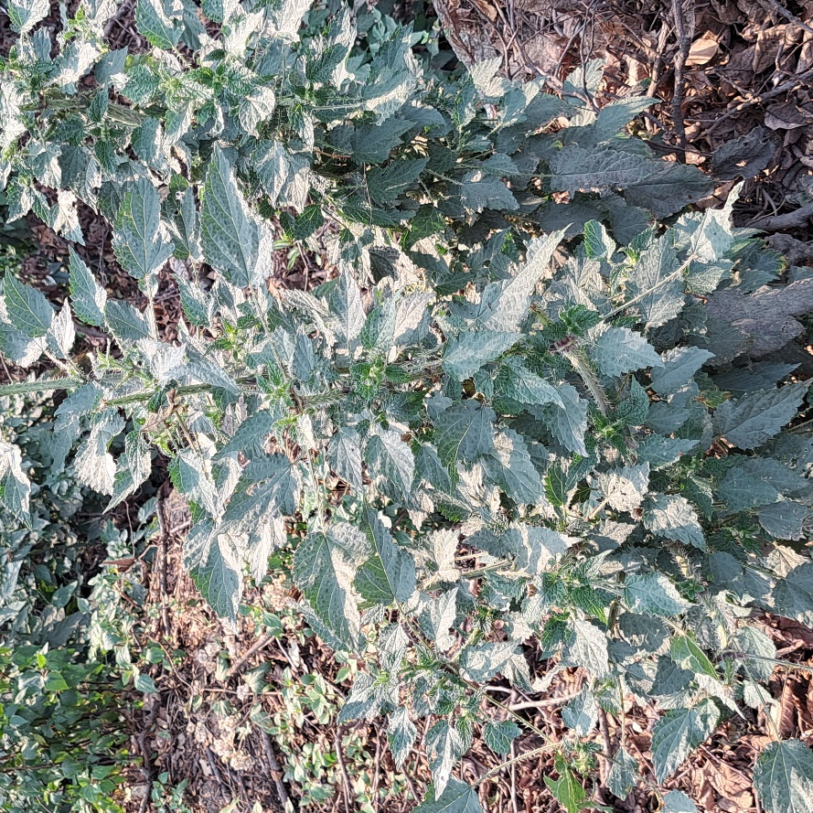

Himalayan Cypress

Dhupi

# Cupressus torulosa

Cupressaceae

Tree

Himalayan cypress has a conical or pyramidal shape, with a broad base which is mostly trimmed to unique shapes for ornamental purposes. The bark of Himalayan cypress tree is thick, fibrous, and reddish-brown or grayish-brown in color. These trees are typically tall, with different plants having different height. They usually grow up to 35 metres tall. It is known for being lightweight, soft, and fragrant. Similarly, this Cypress tree produces small, oval-shaped cones. These cones contain the tree's seeds and can vary in size.

1. Himalayan Cypress is highly valued for its durability, strength, and natural resistance to decay and rot. It is used in various applications, such as construction, woodworking, furniture, cabinetry, flooring, and fences.
2. These trees can be trimmed into various unique shapes. Thus, they help in indoor and outdoor architecture as well.
3. The Himalayan Cypress trees have historical and cultural significance in many regions. They have been used in traditional medicine, herbal remedies, and cultural ceremonies.

The bark of the Himalayan Cypress has a unique and interesting characteristic. When the outer layer of the bark is peeled off or damaged, the inner layer reveals a vibrant reddish-brown color. This distinct coloration adds to the visual appeal of the tree and makes the Himalayan Cypress stand out among other trees in the forest.

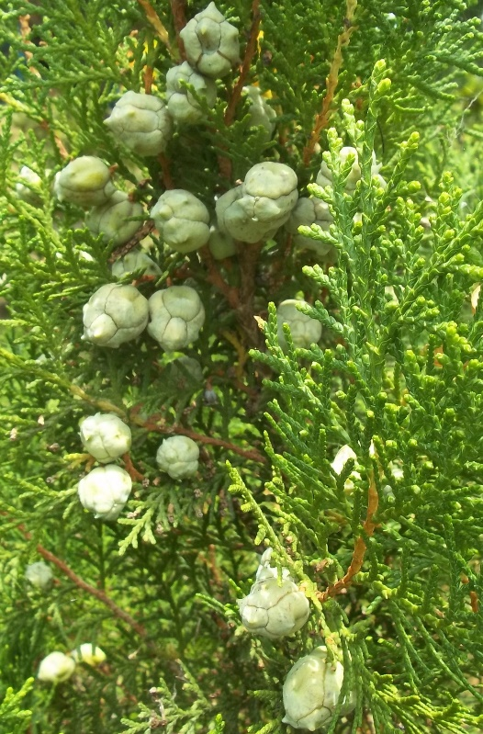

Sago Palm

_________

# Cycas revoluta

Cycadaceae

Tree

The Sago Palm has a cylindrical trunk that can grow up to 3 meters tall. The trunk is covered with old leaf bases, giving it a rough texture. Similarly, the leaves of the Sago Palm are large and feather-like. The leaves can reach lengths of 60 to 120 centimeters. Likewise, the Sago Palm has a fibrous root system that helps anchor the plant and absorb water and nutrients from the soil.

1. Sago Palms are widely valued as ornamental plants due to their attractive appearance. It is often used in gardens, landscapes, and indoor spaces.
2. The Sago Palm is well adapted to dry and arid conditions. It is highly drought-tolerant and can survive in regions with limited water availability.
3. The starch-rich pith of the Sago Palm's trunk, known as "sago," can be processed and used as a food ingredient.

Despite its name, the Sago Palm is not actually a true palm. It is a cycad, a primitive plant that has existed for millions of years. Cycads are often referred to as "living fossils" because they have remained relatively unchanged for millions of years and are considered one of the oldest living plant lineages on Earth.

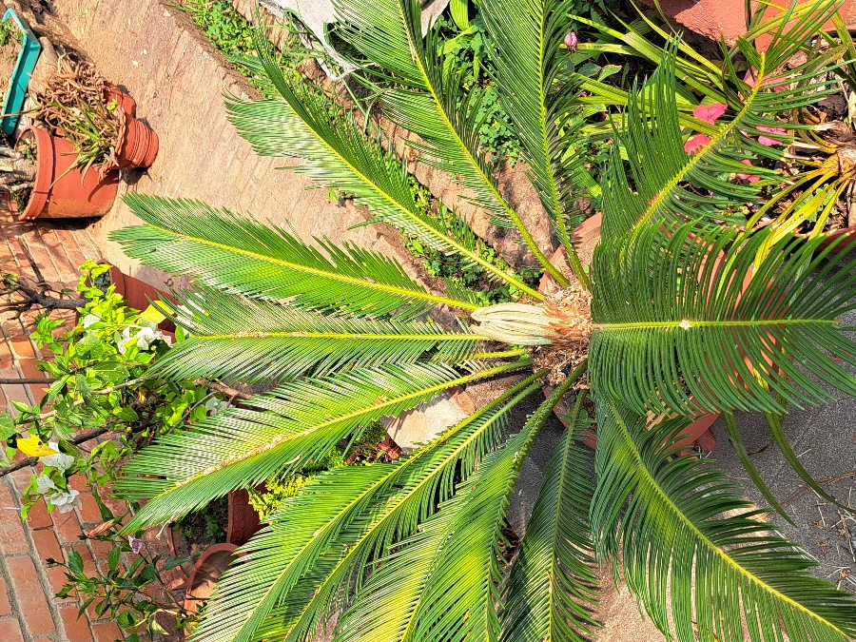

Red Vein Abutilon

____

# Abutilon pictum

Malvaceae

Shrub

Red Vein Abutilon can reach height of 1.5 to 3 meters when fully mature. The leaves of Red Vein Abutilon are generally heart-shaped with medium to dark green color and have prominent red veins that give the plant its common name. The flowers of Red Vein Abutilon are bell-shaped and have a base color ranging from pale yellow to light orange or peach, and striking red veins running through the petals.

1. Red Vein Abutilon is highly valued for its ornamental beauty. Its attractive flowers with red veins create a striking visual display, making it a desirable choice for gardens, landscapes, and ornamental plantings.
2. In some traditional medicinal practices, various parts of the Red Vein Abutilon plant are used for their potential medicinal properties. They are believed to have anti-inflammatory, antioxidant, and other beneficial effects.
3. Red Vein Abutilon, like other plants, may hold cultural and symbolic significance in different regions. It can be associated with traditional beliefs, rituals, and ceremonies. In some cultures, the flowers may symbolize beauty, love, or other virtues.

The flowers of the Red Vein Abutilon are not only visually striking but also have an interesting characteristic. They are known to change color as they age. When the flowers first open, they typically have a lighter base color with distinct red veins. However, as the flowers mature, the base color intensifies, deepening into shades of orange or peach.

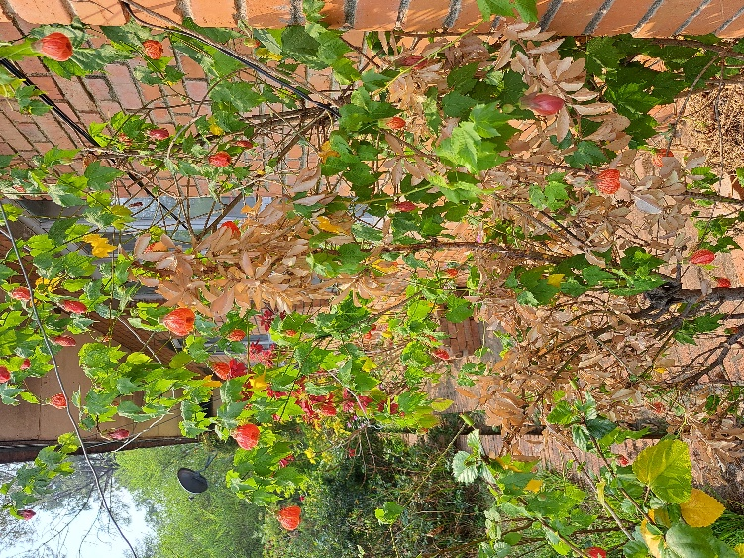

Purple Heart

----

# Tradescantia pallida

Commelinaceae (Spiderworts)

Herb

The stems of the Purple Heart plant are trailing, making it suitable for hanging baskets. Purple Heart plants produce small, three-petaled flowers which are usually pale pinkish-purple in color. The height of this plant can vary from 30 to 45 centimetres depending on growing conditions and care. The Purple Heart plant has a fibrous root system. The roots of the Purple Heart plant are efficient at absorbing moisture and nutrients from the soil.

1. The Purple Heart plant is highly valued for its striking purple foliage. It is commonly used as an ornamental plant in landscaping, gardens, and indoor spaces.
2. Like other plants, the Purple Heart plant contributes to a healthier environment. It absorbs carbon dioxide and releases oxygen, helping to improve air quality.
3. Due to its trailing stems and ability to spread, the Purple Heart plant can be used for erosion control on slopes or areas prone to soil erosion.

The Purple Heart plant is not only known for its vibrant purple foliage but also for its ability to regenerate and propagate easily. Even if you accidentally break off a piece of a Purple Heart plant, it has a high chance of rooting and growing into a new plant. The stem cuttings can be placed in water or directly in well-draining soil, and they will often develop roots and continue to grow.

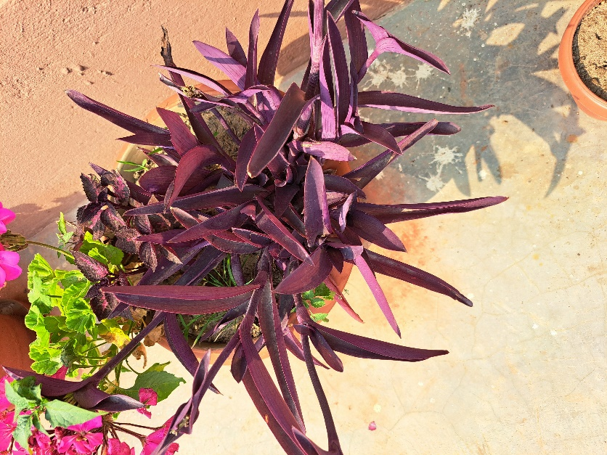

Pumpkin

Pharsi

# Cucurbita pepo

Cucurbits

Creeper

Pumpkin plants have vines that grow along the ground or climb on nearby structures or vegetation. The vines can extend several meters in length. The pumpkin plant has large, broad leaves that are typically green in color and have a rough texture and can reach sizes of up to 30 centimetres in diameter. The most recognizable feature of the pumpkin plant is, of course, the pumpkin itself. Pumpkins come in various shapes, sizes, and colors.

1. Pumpkins are widely consumed as a food source. It is used in various culinary applications, including soups, stews, desserts, etc.
2. Pumpkins are a good source of vitamins A and C, which are beneficial for eye health, immune function, and overall well-being.
3. Pumpkin seeds are pressed to extract oil, which is used in cooking, cosmetics, and traditional medicine. Pumpkin seed oil has a rich flavor and is often used as a salad dressing.

The largest pumpkin ever recorded weighed over 1,179 kilograms. This pumpkin was grown by Mathias Willemijns of Belgium in 2016 and set a new world record. To put it into perspective, that's equivalent to the weight of around 10 small cars or 70 adult humans!

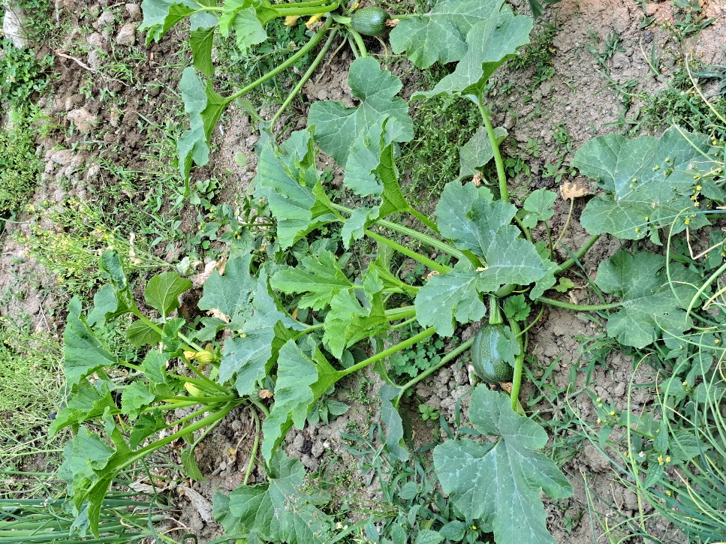

Primrose Jasmine

------

# Jasminum mesnyi

Oleaceae

Shrub

Primrose Jasmine reaches a height of around 1 to 2 meters and has a similar spread. The bark of the Primrose Jasmine is relatively smooth and light brown in color. On older stems, the bark may develop a slightly rough texture. The Primrose Jasmine produces bright yellow, trumpet-shaped flowers that are about 2 to 3 centimeters in diameter. One of the notable features of the Primrose Jasmine is its pleasant fragrance. The flowers emit a sweet, delicate scent that adds to the overall appeal of the plant.

1. The Primrose Jasmine is primarily valued for its attractive yellow flowers and pleasant fragrance. It is commonly used as an ornamental plant in gardens, parks, and landscapes to add beauty and visual appeal.
2. Some people cultivate the plant specifically for its fragrance, and the flowers are used to create perfumes, essential oils, and scented products.
3. The Primrose Jasmine holds cultural significance in some regions where it is grown. It may be associated with traditional beliefs, rituals, or customs and used in religious ceremonies or festivals.

The Primrose Jasmine is sometimes referred to as "The Sunshine of the Winter" due to its ability to bloom during the colder months. While many other plants go dormant or produce fewer flowers in winter, the Primrose Jasmine defies the season by showcasing its bright yellow blossoms.

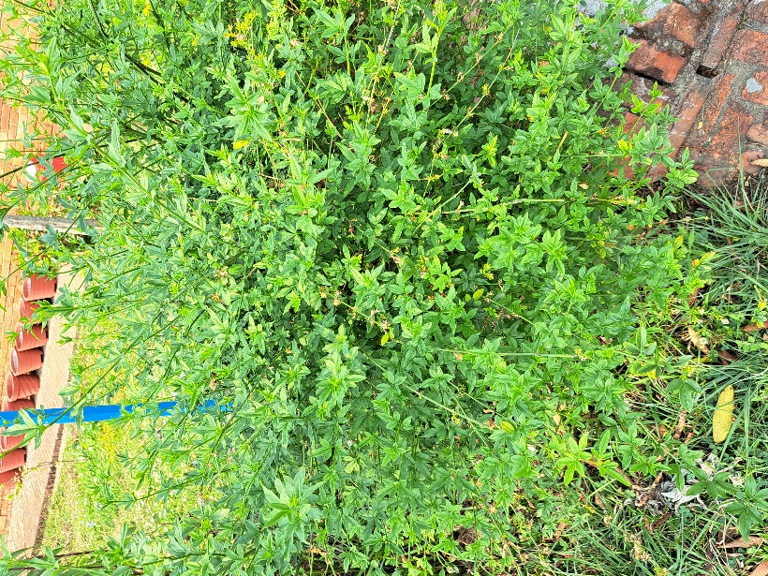

Pot-marigold

Asarfi phool

# Calendula officinalis

Asteraceae

Herb

Pot marigold plants can vary in height, but they typically reach a height of about 30 to 60 cm. The flowers of this plant are large with vibrant colors ranging from yellow to orange. They have a daisy-like appearance, with layers of overlapping petals forming a central circle. The stems branching out from the base are typically green. They are usually slightly rough to the touch. The leaves are arranged alternately along the stems and have a slightly hairy texture. Likewise, Pot marigold flowers have a distinct aromatic scent.

1. The petals of pot marigold are edible and can be used as a colorful decoration in salads, soups, and other dishes. They have a slightly peppery flavor and are also used in soups, meat and rice dishes as well.
2. The yellow and orange petals of pot marigold can be used to produce natural dyes. They can be boiled to extract color and used to dye fabrics, yarns, and other materials.
3. Pot marigold flowers are commonly used in floral arrangements and decorations due to their bright and cheerful colors. They are often included in bouquets, garlands, and wreaths for festive occasions and celebrations.

Pot marigold flowers have a unique quality known as "circadian rhythm." This means that the flowers open and close their petals in response to the time of day. In the morning, when the sunlight intensity is low, the flowers open up, displaying their vibrant petals to attract pollinators. As the day progresses and the sunlight becomes more intense, the flowers close up to protect themselves from excessive heat and potential damage.

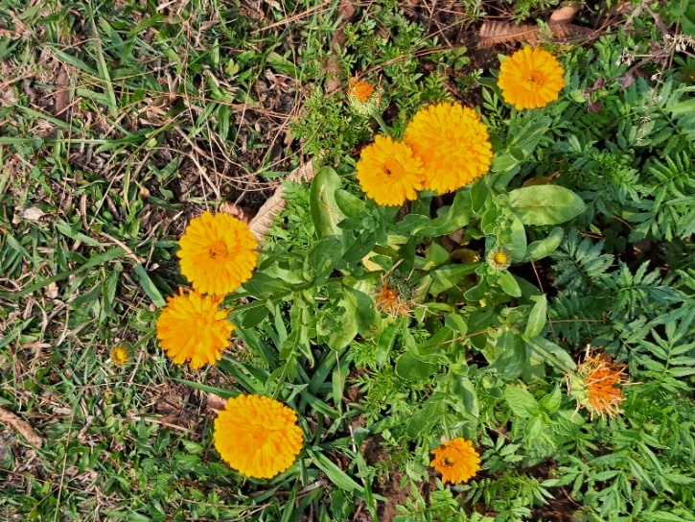

Poinsettia

Lalupate

# Euphorbia pulcherrima

Spurges

Shrub

The most recognizable feature of the poinsettia are its bracts, which are often mistaken for petals. The bracts are large, colorful that come in various shades, including red, pink, white and yellow. The size of Poinsettia is typically around 60 to 120 centimeters in height, but they can grow taller in their natural habitat. Similarly, the flowers of Poinsettia are small and yellow in color and are located at the centre of the bracts.

1. Poinsettias are widely cultivated as ornamental plants, particularly during the holiday season. Their vibrant bracts in shades of red, pink, white, and other colors make them popular for festive decorations.
2. Poinsettias have a long history of use in traditional medicine. Some cultures have utilized different parts of the plant for medicinal purposes, such as treating fevers, skin disorders, and dental issues. However, it's important to note that poinsettias contain a milky sap that can be mildly toxic and cause skin irritation or digestive discomfort if ingested.
3. Poinsettias have become closely associated with celebrations in many cultures. In some traditions, they are used to decorate homes, religious sites, and public spaces.

Poinsettias are photoperiodic plants, meaning their flowering is triggered by the length of daylight. In order to produce their colorful bracts, poinsettias require a specific period of darkness each day. To initiate blooming, poinsettias need at least 12 to 14 hours of uninterrupted darkness for several weeks. The specific light requirements highly impact their flowering schedule!

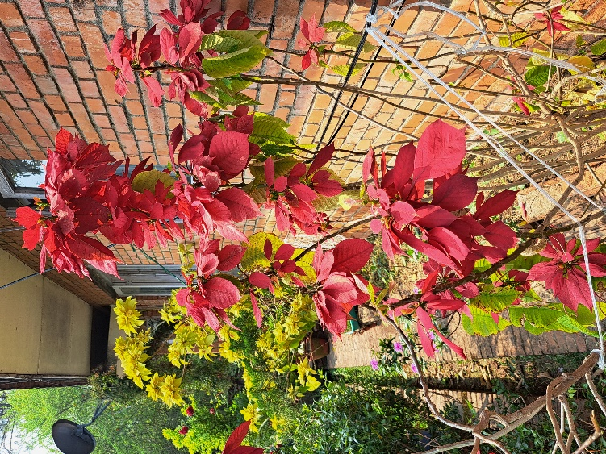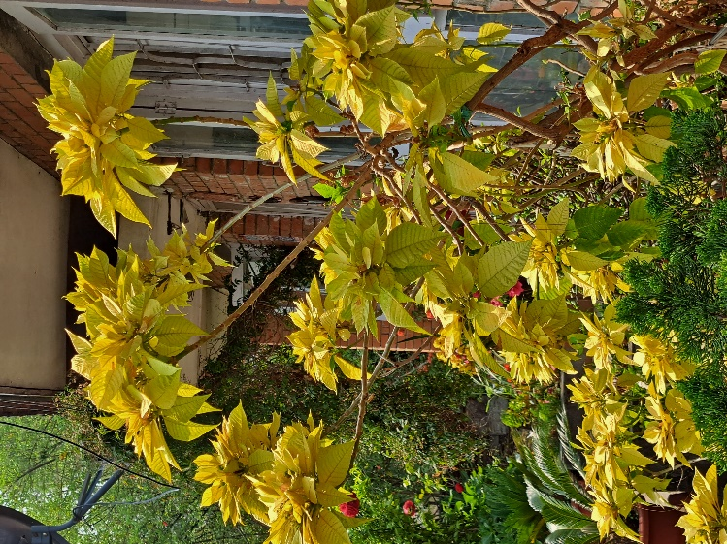

Polka Dot Plant

------

# Hypoestes phyllostachya

Acanthaceae

Herb

Polka Dot Plants are relatively small in size, making them suitable for indoor cultivation. They usually reach a height of around 5 to 30 cm, although they can grow slightly taller under optimal conditions. Similarly, the leaves of the Polka Dot Plant, which are the most striking feature of this plant, are generally oval in shape and have a soft, hairy texture. The leaves are typically green, but what makes this plant unique are the colorful spots or dots that cover the leaf surface.

1. Polka Dot Plants are commonly grown as houseplants due to their attractive and colorful foliage. Their polka dot-patterned leaves bring a lively and eye-catching element to indoor spaces, making them popular choices for adding visual interest and beauty.
2. Polka Dot Plants contribute to indoor air purification by filtering out toxins and improving air quality.
3. The leaves of the Polka Dot Plant can be used for natural dyeing projects. The vibrant colors and patterns on the leaves can transfer onto fabrics, creating unique and visually appealing patterns.

The Polka Dot Plant is sometimes referred to as the "freckle face" plant due to its unique leaf patterns. Just like freckles on human skin, the Polka Dot Plant's leaves are adorned with small spots or dots of various colors, including pink, red, white, and even purple. These spots give the plant a playful and whimsical appearance, earning it the endearing nickname of "freckle face" among plant enthusiasts.

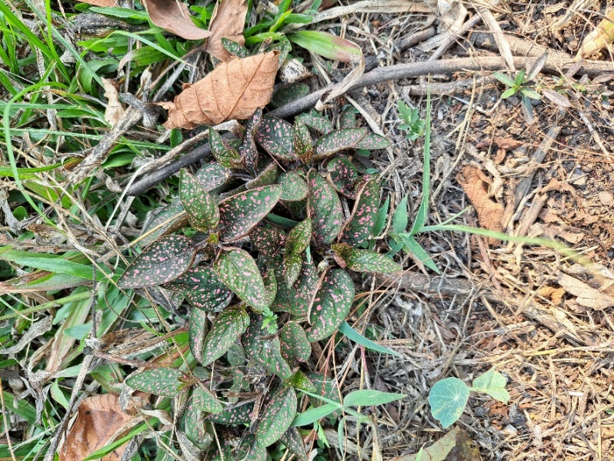

Pepinomelon

------

# Solanum muricatum

Solanaceae/Nightshade

Shrub

The size of the pepino melon plant can vary, but it typically reaches a height of about 60 to 120 centimeters. Similarly, the flowers of the pepino melon are small and bell-shaped. They are typically white or pale purple and can be found in clusters along the stems. The fruit of the pepino melon is the most notable feature. It is oval-shaped, with a smooth and waxy skin that can range in color from yellow to pale green or even purple. The fruit is typically about 5 to 10 centimeters in length.

1. The pepino melon is mainly grown for its fruit, which is enjoyed fresh or used in various culinary applications. When ripe, the sweet and juicy flesh of the pepino melon can be eaten raw, similar to other melons.
2. In traditional medicine, certain parts of the pepino melon plant have been used for their potential medicinal properties. For example, the leaves have been used topically as a poultice for skin conditions.
3. Pepino melons are a good source of vitamins A and C, as well as dietary fiber. They also contain minerals like potassium and calcium.

The pepino melon is sometimes referred to as the "melon pear" due to its unique combination of flavors. When fully ripe, the pepino melon has a taste that is often described as a cross between a melon and a pear. This interesting blend of flavors gives the pepino melon a distinctive and delightful taste that sets it apart from other melon varieties.

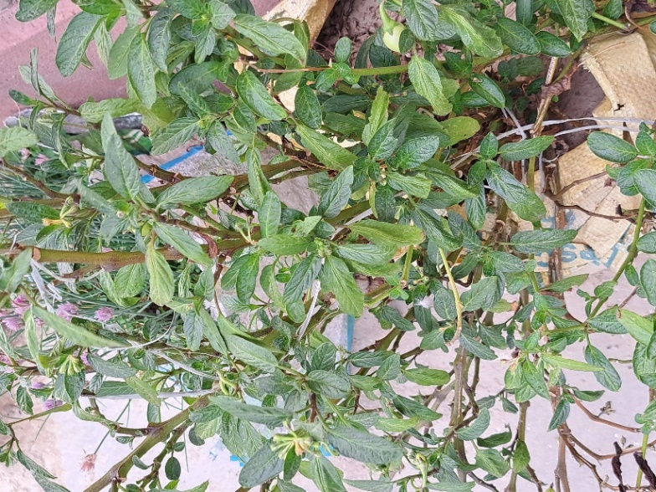

Peepal Tree

Peepal

# Ficus religiosa

Moraceae

Tree

Peepal trees can grow quite large, reaching heights of 20 to 30 meters or even more, depending on the environmental conditions. The bark of the Peepal tree is smooth, light gray, and often becomes mottled as the tree ages. Similarly, these trees have ariel roots which grow from the branches and hang down to the ground, giving the tree a unique appearance. Likewise, Peepal trees are deciduous, which means they shed their leaves during the dry season and grow new ones in favorable conditions.

1. The Peepal tree is considered sacred in several religions, especially in Hinduism, Buddhism, and Jainism. It is often associated with various deities and gods and is considered as a symbol of wisdom, knowledge, and enlightenment.
2. While the Peepal tree is not primarily cultivated for timber, its wood can be used for making small utility items and craftwork.
3. As a large deciduous tree, the Peepal contributes to the environment by providing shade and cooling the surrounding areas. It also acts as habitat and food for various animals.

The Peepal tree's large heart-shaped leaves, which are typical of the species, are prone to water loss due to their size and exposure to the elements. To cope with water scarcity and protect itself from dehydration, the tree selectively sheds some of its leaves. This self-pruning behavior ensures that the tree retains only the essential number of leaves it can sustain with available water resources.

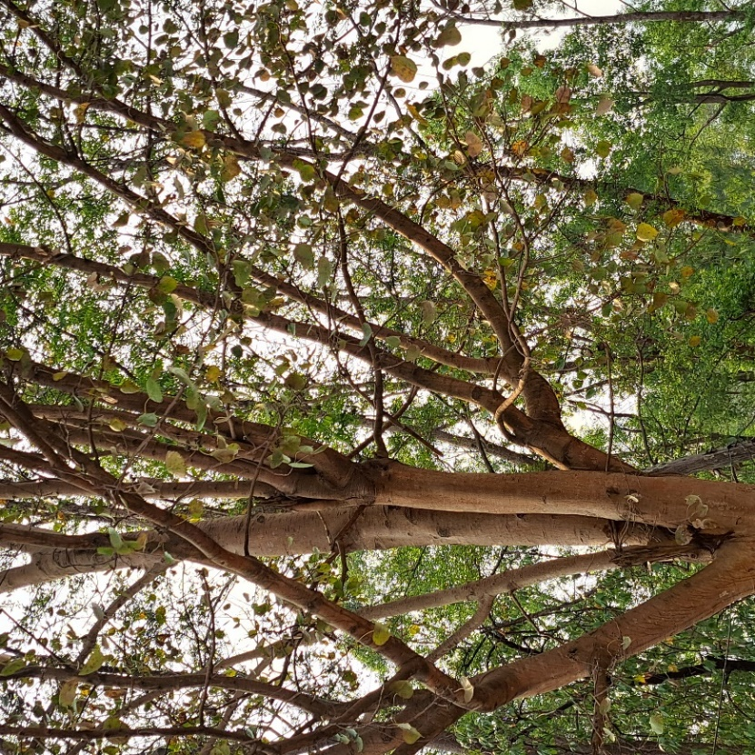

Peanut Cactus

Peanut Cactus

# Echinopsis chamaecereus

Cactaceae

Herb

The Peanut Cactus is a relatively small cactus, typically growing up to about 10 to 20 centimeters in height and around 6 centimeters in diameter. It has cylindrical shape, with multiple ribs running along its length. The stem is divided into segments that give it a segmented appearance. Similarly, the flowers of this plant are beautiful, funnel-shaped flowers and are relatively large compared to the size of the cactus, and they come in various colors, including pink, red, orange, and sometimes yellow or white.

1. The Peanut Cactus is highly valued for its attractive and unique appearance. Its cylindrical shape, segmented stems, and colorful flowers make it a popular choice for ornamental gardening and indoor plant displays.
2. Due to its small size and adaptability to indoor conditions, the Peanut Cactus is commonly grown as a houseplant. It can thrive in containers and makes for an excellent addition to windowsills or small spaces.

The Peanut Cactus, known for its "peanut-like" appearance, can "dance" with the sun! Its flowers follow the sunlight, facing upward during the day and gracefully turning downward as evening approaches. This unique "circadian flower movement" helps protect the flowers from nighttime dew and potential pests, adding to the cactus's charm and allure.

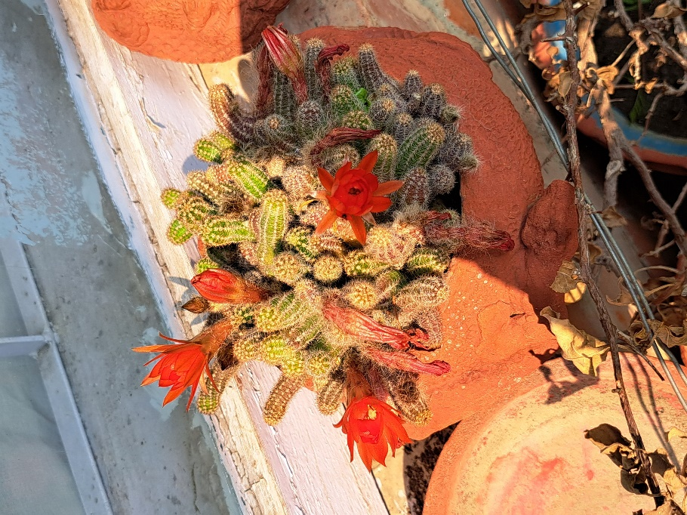

Paperflower

Bagan-Bilas

# Bougainvillea glabra

Nyctaginaceae

Shrub

The leaves of Bougainvillea glabra are simple, ovate to elliptical in shape, and have a smooth texture. They are dark green in color and can be up to 4 to 13 centimeters long. The actual flowers of this plant are small and not much recognized but what really makes this plant unique is its bracts. The bracts are large, papery, and brightly colored which can come in various hues, including pink, purple, red, orange, yellow, and white.

1. One of the primary uses of Bougainvillea glabra is its ornamental value. Its vibrant and showy bracts in various colors make it a popular choice for landscaping, gardens, and decorative purposes.
2. The vigorous growth and sprawling nature of Bougainvillea glabra makes it effective for erosion control. It can be planted on slopes and hillsides to help stabilize the soil and prevent erosion.

The plant is named after Louis Antoine de Bougainville, a French navigator and explorer who led the first French circumnavigation of the globe in the 18th century. The genus "Bougainvillea" was named in his honor.

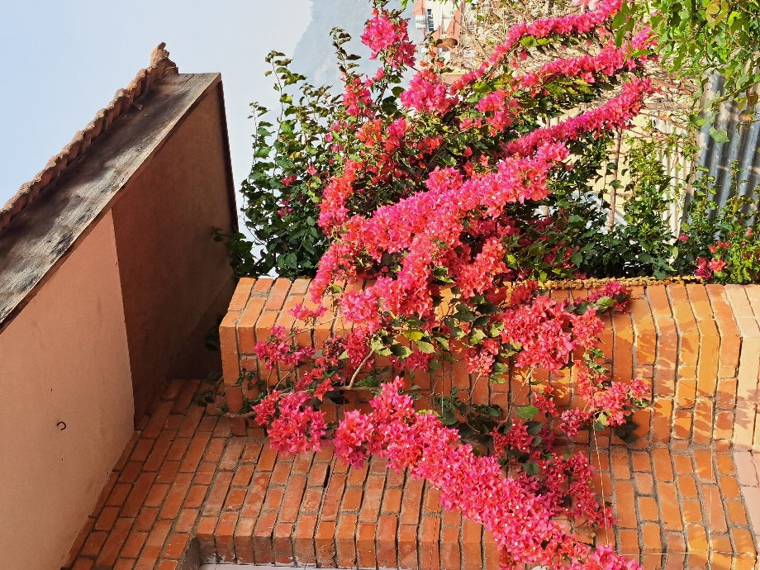

Pansy

Putali Phul

# Viola × wittrockiana

Violaceae

Herb

Pansy flowers vary in size, but they typically have a diameter of around 5 to 7.5 centimeters. The flowers of this plant are large with five petals arranged in a symmetrical pattern. The petals come in various colors, including shades of purple, yellow, orange, blue, white, and combinations of these colors and are velvety in texture, which gives them a soft and slightly fuzzy appearance. Likewise, some pansy varieties may have a subtle, pleasant fragrance, though not all varieties exhibit a scent.

1. Pansies are primarily cultivated for their attractive flowers. They come in a wide range of colors and patterns, making them a popular choice for adding vibrant displays to gardens and landscapes.
2. Pansies are edible flowers and can be used to decorate and add color to salads, desserts, and other dishes.
3. Pansies have a history of traditional medicinal uses. Some cultures have used pansy extracts for their alleged anti-inflammatory, expectorant, and diuretic properties.

The name "pansy" is derived from the French word "pensée," which means "thought." Pansies got this name because their unique face markings resemble a human face, and it was believed that the flower's appearance was like a person lost in thought. As a result, pansies have been associated with various symbolic meanings, including remembrance, reflection, and free thinking. These delightful flowers have a rich cultural history and continue to captivate people with their beauty and charm.

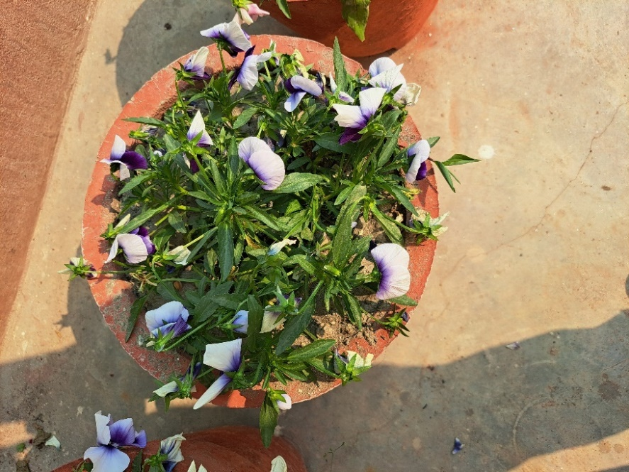

Spinach

Palungo Saag

# Spinacia oleracea

Amaranthaceae

Herb

The leaves of spinach are its most prominent feature whose size can vary, but they are generally medium-sized, ranging from 2 to 6 inches in length. They are dark green, broad, and have a smooth or slightly crinkled surface. The stem of this plants is tender and non-woody that are often green or purplish in color. The stems are relatively thin and not as significant as the leaves. Similarly, the root system of spinach consists of a fibrous network of roots that anchor the plant in the soil and absorb water and nutrients.

1. Spinach is a powerhouse of essential nutrients. It is rich in vitamins, including vitamin A, vitamin C, vitamin K, and folate. It also contains minerals like iron, calcium, potassium, and magnesium.
2. The high levels of potassium and folate in spinach help regulate blood pressure and support heart health. The antioxidants present in spinach may also help reduce oxidative stress and inflammation, further benefiting cardiovascular health.
3. Spinach is a versatile vegetable used in various culinary applications. It can be enjoyed raw in salads or cooked in a variety of dishes such as spinach soups, stews, quiches, and pasta dishes.

Spinach is a "photoperiodic" plant, which means its growth and reproductive processes are influenced by the length of daylight it receives. As the days get longer in spring and early summer, spinach starts to bolt, which means it rapidly produces a flower stalk and goes to seed.

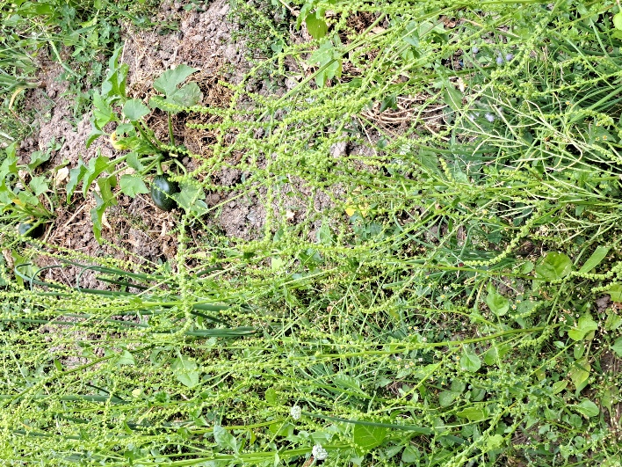

Orange

Suntala

# Citrus sinensis

Rutaceae

Tree

Orange trees are small to medium in size. They typically grow between 6 to 9 meters tall, but some plants may remain smaller. The leaves of an orange tree are glossy, dark green, and oblong or oval in shape. They are typically 10 to 15 cm long and have a pointed tip. Similarly, the fruit of the orange tree, commonly known as an orange, is a type of citrus fruit. Oranges are round and typically bright orange in color, but the shade can vary depending on the specific variety. The skin is thick and somewhat rough to touch, with a sweet to tangy flesh inside that is divided into segments.

1. Oranges, being citrus fruits, are renowned for their high vitamin C content which is essential for a healthy immune system, collagen production, and the absorption of iron from plant-based foods.
2. The most well-known use of oranges is as a delicious and nutritious fruit. Oranges are consumed fresh, juiced, or used in various culinary applications such as desserts, salads, and beverages.
3. Oranges are a primary source of orange juice, which is one of the most popular fruit juices worldwide. The orange plant plays a crucial role in the beverage industry, providing a refreshing and nutritious drink.
4. The pleasant and citrusy scent of oranges is utilized in perfumes, cosmetics, and various flavorings for food and beverages.

Oranges are not naturally occurring fruits. They are actually a hybrid of two other citrus fruits – the pomelo (Citrus maxima) and the mandarin (Citrus reticulata). The exact origins of oranges are believed to trace back to ancient Southeast Asia.

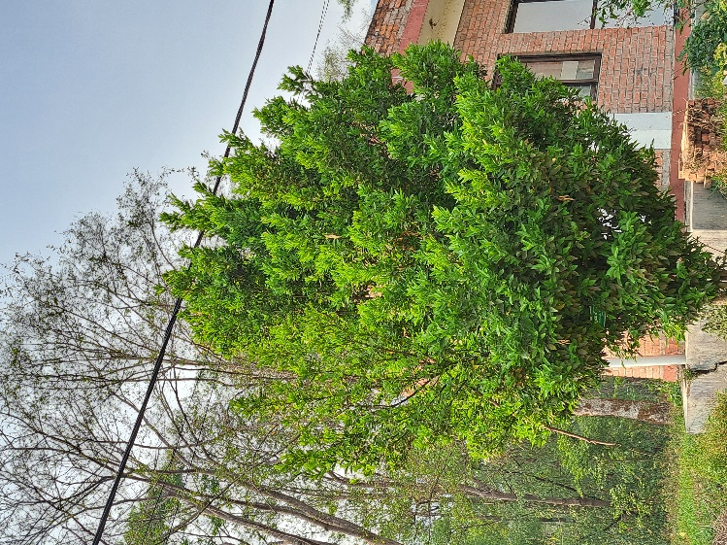

Onion

Pyaj

# Allium cepa

Amaryllidaceae

Herb

The most recognizable part of the onion is the bulb, also known as the onion bulb or onion head. It is a round to slightly flattened, underground storage structure that stores nutrients for the plant. Onions can also range in size from small pearl onions to large, softball-sized bulbs. The size can depend on the specific variety and growing conditions. Similarly, onions have a strong, pungent aroma, especially when cut or sliced. This aroma is due to volatile compounds released from the onion's cells.

1. Onions are one of the most versatile vegetables used in cooking worldwide. They add flavor and aroma to a wide variety of dishes, including soups, stews, sauces, salads, stir-fries, and many more.
2. Onions are a good source of essential nutrients such as vitamin C, vitamin B6, potassium, and dietary fiber. They contribute to a balanced and nutritious diet.
3. Onions contain compounds that have been associated with heart health benefits, including the potential to reduce blood pressure and improve cholesterol levels.

Cutting onions can make you cry because they release a chemical irritant called syn-propanethial-S-oxide. When you slice into an onion, it damages its cells, causing the release of this irritant. When the syn-propanethial-S-oxide comes into contact with your eyes, it stimulates your tear glands to produce tears, leading to the familiar teary-eyed reaction. To reduce tears while cutting onions, you can try chilling the onion in the refrigerator before cutting, cutting the onion under running water, or using a very sharp knife to minimize cell damage. Additionally, some people wear goggles or use special onion-chopping gadgets to avoid the tear-inducing effects.

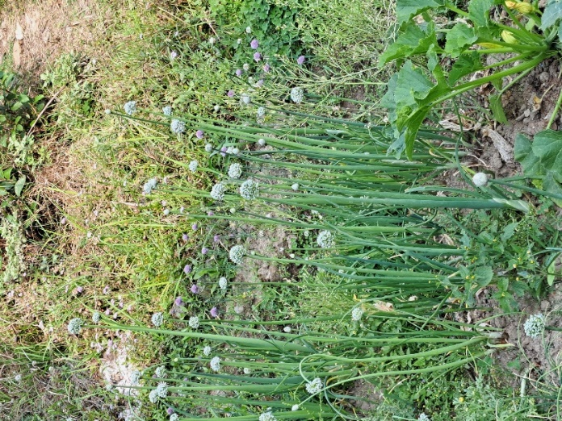

Morning Glory

Nishodhi

# Ipomoea

Convolvulaceae

Shrub

The leaves of morning glory plants are heart-shaped or palmate, meaning they have several lobes radiating from a central point. The leaves are usually green, but some species may have variations in color and patterns. Similarly, morning glory flowers are trumpet-shaped and come in a wide array of colors, including white, pink, red, purple, blue, and combinations of these colors. The flowers typically have a diameter of 5 to 10 centimeters. Likewise, the roots of morning glory plants are typically fibrous and shallow, allowing them to adapt well to various soil conditions.

1. Morning glory plants are widely cultivated for their attractive and colorful flowers. They are a very popular choice in gardens, landscapes, and hanging baskets, adding beauty and charm to outdoor spaces.
2. Morning glory plants are known to improve soil quality by reducing soil compaction, adding organic matter as they decay, and enhancing soil aeration.

The name "morning glory" comes from the unique characteristic of the flowers, which bloom in the early morning and then gradually close up during the day. The scientific term for this phenomenon is "nyctinasty." The flowers respond to light, and they close in the afternoon or during cloudy weather. This behavior helps protect the flower's reproductive parts from potential damage or exposure to adverse weather conditions. Once evening comes or when the weather improves, the flowers will often reopen, ready to greet the next morning's light again.

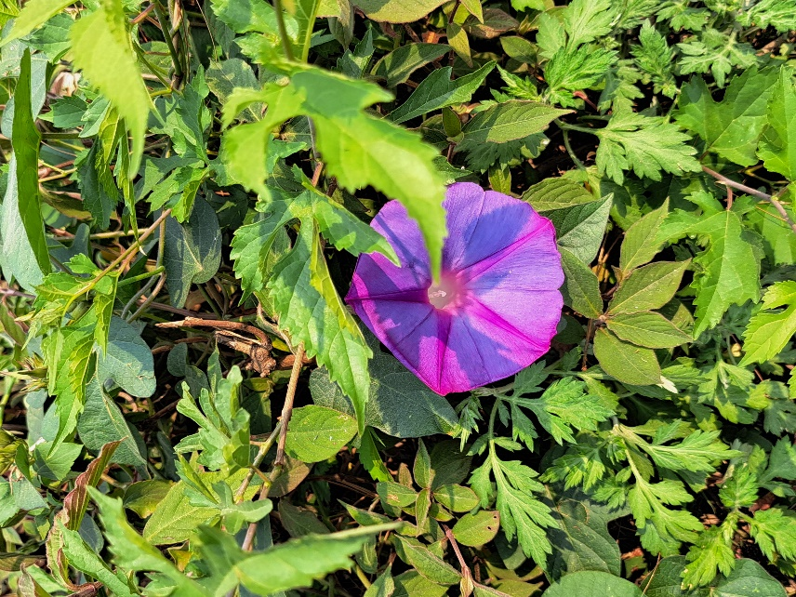

Butter Daisy

Butter daisy

# Melampodium divaricatum

Asteraceae

Herb

Similarly, the leaves of Melampodium are generally simple, alternate, and have an elongated or lanceolate shape. The margins of the leaves may be smooth or slightly toothed. Butter Daisy produces bright yellow, daisy-like flowers with a characteristic central disc like petals. The flowers are about 2.5 to 3.8 centimeters in diameter. This plant typically blooms during the warmer months, producing a profusion of flowers that can last for an extended period.

1. Butter Daisy is widely cultivated as an ornamental plant in gardens and landscapes. Its bright and cheerful yellow flowers add a splash of color to outdoor spaces, making it popular among gardeners and horticulturists.
2. Butter Daisy is relatively easy to grow and care for. It is drought-tolerant and can thrive in a variety of soil conditions, making it a suitable choice for low-maintenance gardening.

Butter Daisy is sometimes referred to as "Blackfoot Daisy" because of its unique characteristic of having dark-colored, almost black, stems and foliage. This distinctive feature sets it apart from many other flowering plants and adds to its charm as an ornamental plant in gardens and landscapes. Despite its delicate appearance, the Butter Daisy is quite hardy and can withstand a range of growing conditions, making it a favorite among gardeners looking for a resilient and beautiful addition to their outdoor spaces.

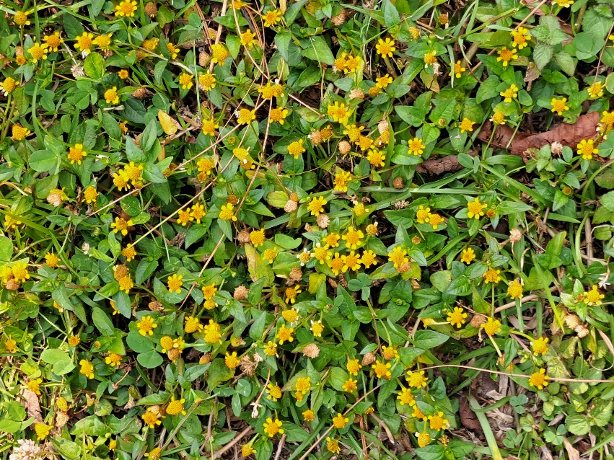

Mango

Aap

# Mangifera indica

Anacardiaceae

Tree

Mature mango trees can reach an impressive height of 9 to 30 meters, depending on the variety and growing conditions. The leaves of the mango tree are large, lance-shaped, and leathery. They are typically dark green on the upper surface and lighter green on the underside. Similarly, Mango trees produce small, fragrant flowers in large inflorescences called panicles. The flowers are typically yellowish-white or cream-colored and have five petals. The mango fruit is one of the most popular and sought-after fruits in the world. It is large and oval-shaped, with a single flat seed in the center. The fruit's skin can vary in color, ranging from green when unripe to shades of yellow, orange, or red when ripe.

1. Mangoes are highly nutritious and rich in vitamin C, vitamin A, vitamin E and minerals. They are a good source of dietary fiber and antioxidants, making them a healthy addition to the diet.
2. Mangoes are used in various food products, such as jams, jellies, chutneys, pickles, and dried fruit snacks. The fruit is also processed into beverages like mango juice, nectar, and mango lassi, a popular yogurt-based drink.

Mangoes are often called the "king of fruits" due to their popularity, delicious taste, and widespread cultivation. They have been cultivated by humans for over 4,000 years and are believed to have originated in South Asia, particularly in present-day India and Myanmar.

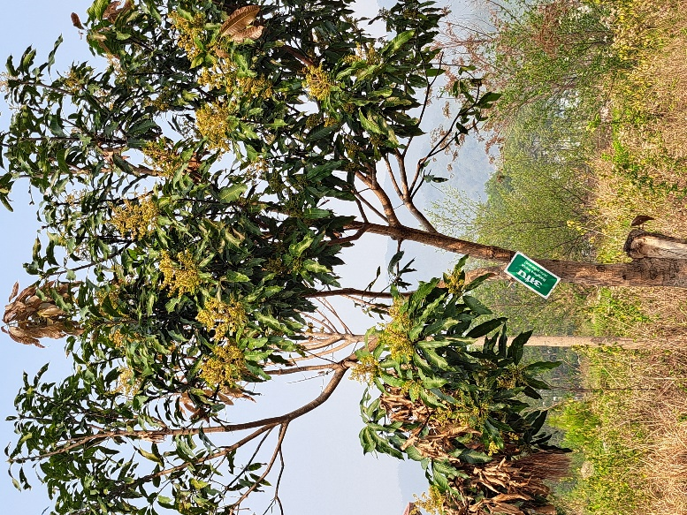

Madagascar Periwinkle

# Catharanthus roseus

Apocynaceae

Shrub

The Madagascar Periwinkle is a small shrub, typically growing to a height of about 30 to 90 centimeters tall. The leaves of the Madagascar Periwinkle are dark green, glossy, and have a spear shaped which are arranged opposite each other along the stem. Similarly, the flowers of this plant are typically five-petaled and come in various colors, including pink, white, lavender, and shades of purple. The center of the flower often has a contrasting eye. Likewise, the Madagascar Periwinkle has a shallow and fibrous root system.

1. The Madagascar Periwinkle is widely cultivated as an ornamental plant in gardens, parks, and landscapes due to its attractive and colorful flowers.
2. In some traditional medicinal systems, various parts of the Madagascar Periwinkle have been used to treat various ailments, such as diabetes, high blood pressure, and infections.

The Madagascar Periwinkle is not only known for its medicinal properties but also for its role in the world of fairy tales and folklore. In some cultures, the Madagascar Periwinkle is associated with tales of love and romance. It is believed that if you give a bouquet of Madagascar Periwinkle flowers to someone you love, it will bring good luck and strengthen the bonds of affection between you. This charming and colorful flower has captured the imagination of people throughout history and continues to be cherished for its beauty and symbolism of love and good fortune.

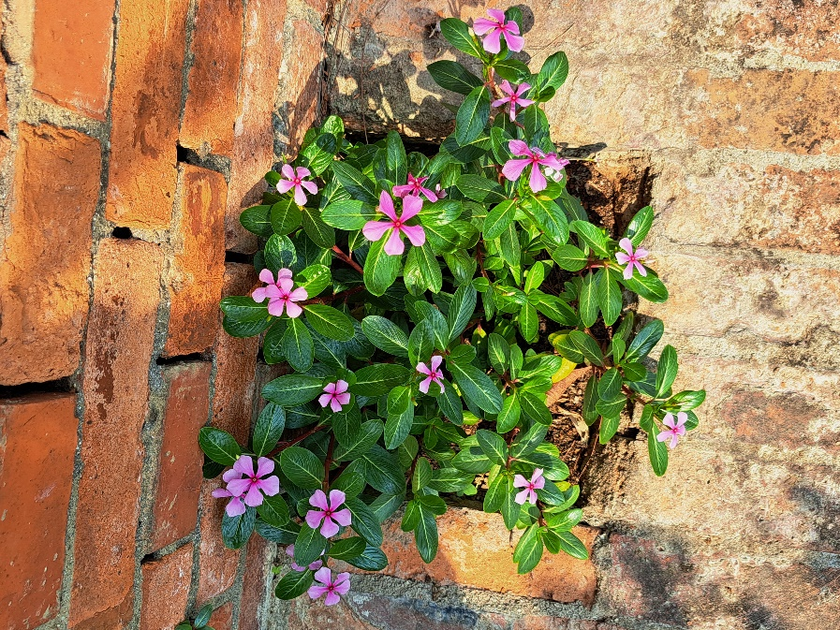

Taro

Karkalo

# Colocasia esculenta

Araceae

Herb

Taro plants have large, green, heart-shaped leaves that can range in size from small to quite large, depending on the variety and growing conditions. The stems of the taro plant emerge from the underground corms and support the leaves. The stems can be solid or slightly hollow, and they vary in color and thickness. Similarly, they have a fibrous root system that grows from the corm. These roots help anchor the plant in the soil and absorb water and nutrients.

1. Taro corms are a good source of dietary fiber, vitamins (such as vitamin A, C, and some B vitamins), and minerals.
2. Taro is mainly used as a food source in many cultures around the world. The starchy corms of the plant are a rich source of carbohydrates and are used in a variety of culinary dishes.
3. Certain ornamental varieties of taro are grown for their attractive foliage and are used as decorative plants in gardens and landscapes.

The taro plant has a unique defense mechanism to deter herbivores. The corms and leaves of the taro plant contain calcium oxalate crystals, which are needle-like structures that can cause irritation and a burning sensation when ingested. This is a natural defense mechanism that discourages animals from eating the plant. Humans cook to eat the taro plant, which destroys the defense system of the plant.

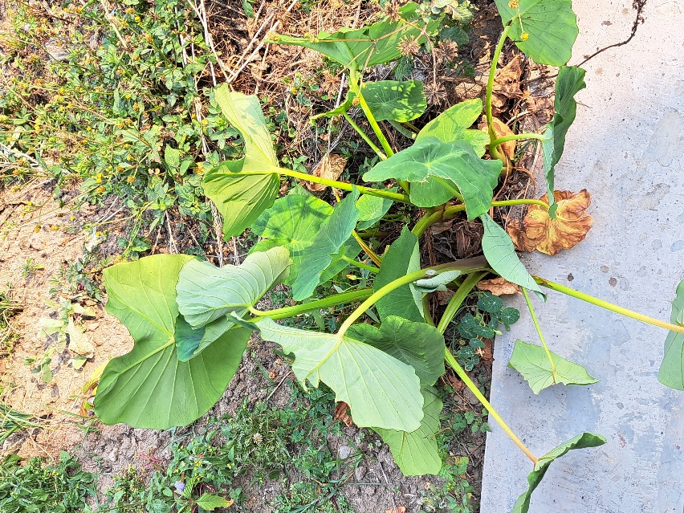

Chayote/Squash

Ishkus

# Sechium edule

Cucurbitaceae

Herb

The most recognizable part of the chayote plant is its fruit, which is often referred to as a chayote squash or vegetable pear. The fruit is green and wrinkled, resembling a pear or a gourd. It has a mild, crisp texture and can vary in size. Chayote is an herbaceous climbing vine that can grow quite long. It produces tendrils that help it cling to structures or other plants as it climbs. Similarly, the leaves of it are large, smooth, and heart-shaped.

1. Chayote fruits are usually pear-shaped and can be eaten both raw and cooked. They have a mild, crisp texture and a subtle flavor, making them suitable for salads, stir-fries, soups, and various culinary dishes.
2. Chayote fruits are low in calories and fat while being a good source of dietary fiber, vitamin C, vitamin B6, and folate.
3. The chayote plant's vining nature and attractive foliage can make it a decorative addition to gardens and landscapes.

Chayote has a unique characteristic where it's known for its ability to grow a new plant from the fruit itself. If you cut a chayote fruit in half and let it dry for a while, you can plant it in soil and it will sprout into a new chayote plant.

Lettuce

Salad

# Lactuca sativa

Asteraceae

Herb

The most distinctive feature of lettuce is its leaves. They can vary in shape, size, color, and texture depending on the variety and are usually arranged in a rosette pattern. Lettuce leaves can be green, red, purple, or even variegated. The intensity of color often depends on the variety and growing conditions. Similarly, lettuce has a shallow root system that spreads out rather than growing deep into the soil. The stem of lettuce is usually short and connects the leaves to the base.

1. Lettuce is a staple ingredient in salads and sandwiches. It provides a refreshing and crunchy texture to dishes, making it a popular choice for adding volume and nutrition to meals.
2. Lettuce is low in calories and a good source of vitamins, minerals, and dietary fiber. It contains vitamins A, C, and K, as well as folate, iron, and potassium.
3. Lettuce has a high-water content, contributing to hydration and providing a way to increase water intake through dietary sources.

Lettuce is one of the oldest cultivated vegetables known to humanity. It has been grown for thousands of years and has a rich history dating back to ancient Egypt and Greece. The ancient Egyptians believed that lettuce had aphrodisiac properties, and it was often included in feasts and ceremonies. The Greek philosopher and naturalist, Aristotle, mentioned lettuce in his writings, and the plant's popularity continued to spread throughout the Roman Empire and beyond

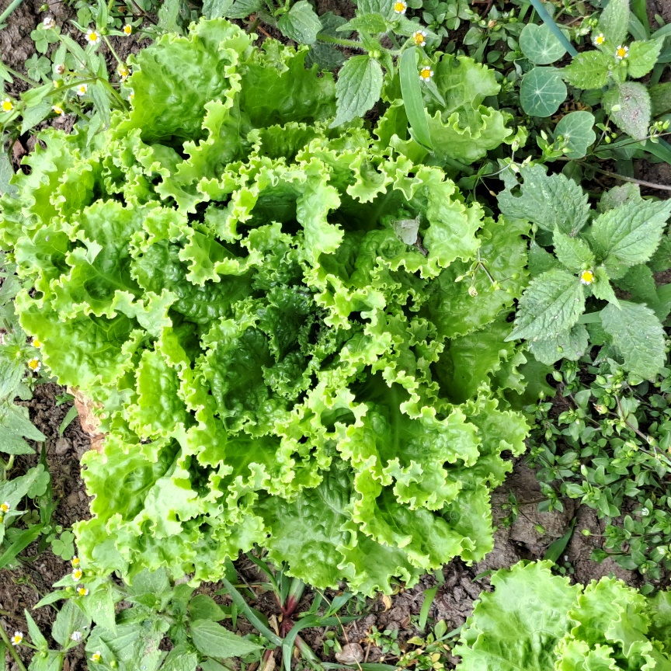

Floss flower

# Ageratum houstonianum

Asteraceae

Herb

The most notable feature of the floss flower is its flower heads. These flower heads are composed of numerous tiny individual flowers clustered together. The flower heads have a fluffy, tufted appearance. Likewise, the stems of the floss flower are usually erect and slightly hairy. They may have a reddish or purplish tinge. Floss flowers typically grow to a height of about 15 cm to 60 cm, depending on the variety and growing conditions.

1. The floss flower is grown for its attractive and colorful flower heads, which come in shades of blue, purple, pink, and white. It adds a splash of color to gardens, borders, and containers.
2. The vibrant blooms of floss flower can attract pollinators like bees and butterflies to your garden, contributing to overall biodiversity and the health of your ecosystem.

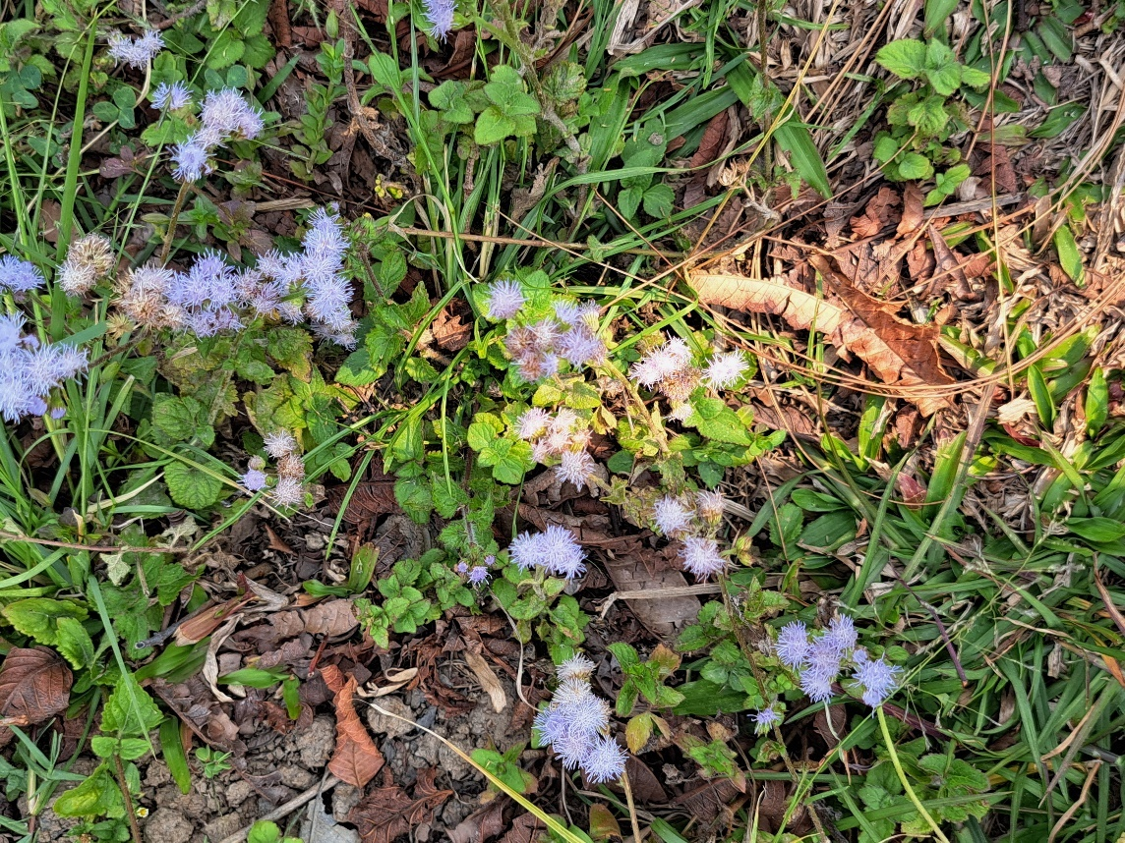

False Heather

# Cuphea hyssopifolia

Lythraceae

Shrub

False heather is a small, low-growing plant that typically reaches a height of about 30 to 45 cm and spreads to a similar width. False heather produces numerous small, tubular flowers that are clustered along the stems. The flowers are typically in shades of pink, although there are also white and lavender varieties available. Similarly, the leaves are tiny, narrow, and lance-shaped and are typically small and densely packed along the stems.

1. False heather is primarily grown for its ornamental value. Its small, delicate flowers and dense foliage make it a charming addition to gardens, landscapes, and container gardens.
2. Due to its low-growing and spreading nature, false heather can be used as a ground cover to fill in spaces between larger plants or in areas where grass might be difficult to grow.

Despite its common name "false heather," false heather is not actually related to true heather plants which belong to the Ericaceae family. True heather is a different type of flowering plant with a similar appearance but distinct botanical characteristics. False heather, on the other hand, belongs to the family Lythraceae and is native to Mexico and parts of Central America. So, the name "false heather" reflects its visual similarity to true heather but indicates its different botanical lineage.

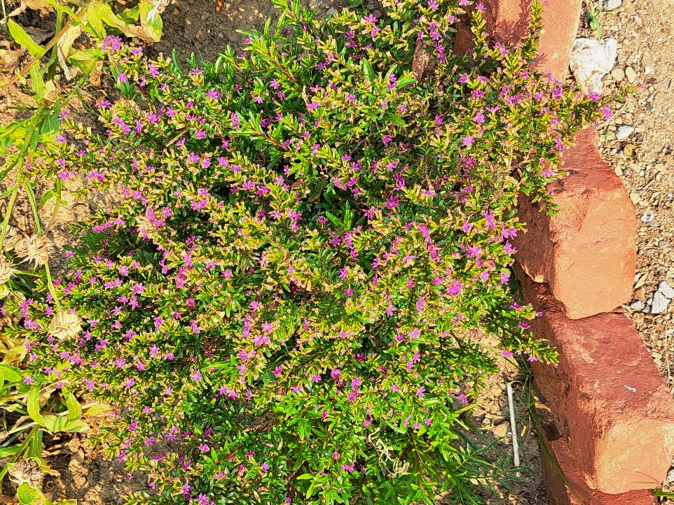

Doubtful knight's spur/Larkspur

# Consolida ajacis

Ranunculaceae

Herb

The flowers of Consolida ajacis are the most distinctive feature. They grow on long, slender stalks and form spikes or racemes. Larkspur flowers come in a range of colors, including various shades of blue, purple, pink, white, and sometimes even red. On average, larkspur plants typically reach a height of about 60 to 90 centimeters), although some cultivars can grow taller. Likewise, the leaves are typically green and alternate along the stems and are often lobed and have a somewhat fern-like appearance.

1. Consolida ajacis is primarily cultivated as an ornamental plant due to its beautiful and unique flowers. It adds vertical interest and vibrant color to gardens, flower beds, and borders.
2. Larkspur flowers have been used as a natural source of dye for textiles and fabrics. Different parts of the plant can yield various shades of color.

The name "larkspur" has an interesting origin. It is said that the name "larkspur" comes from the shape of the flower's spur, which resembles the spur found on the hind legs of a lark, a small songbird. This unique and imaginative association between the flower's structure and the characteristics of a bird gives larkspur its charming and memorable name.

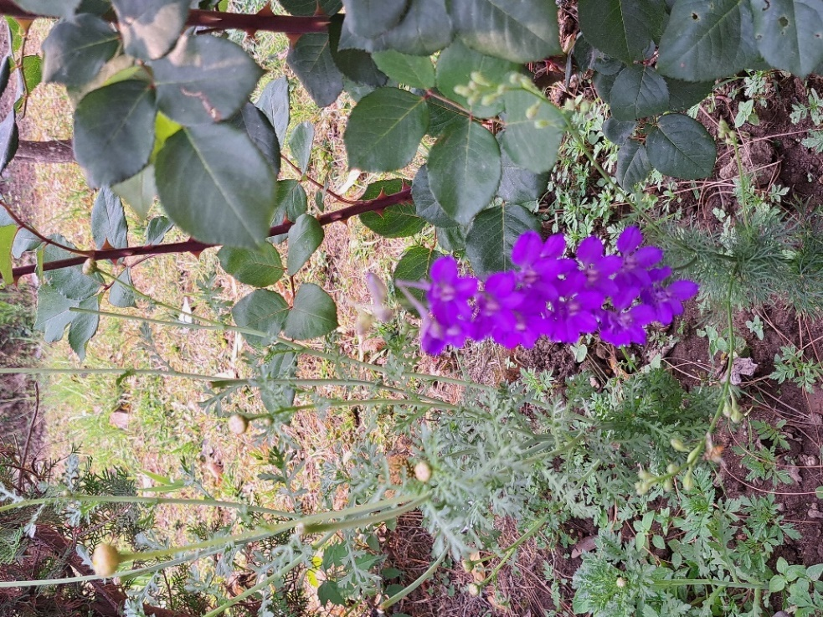

Dallis grass

# Paspalum dilatatum

Poaceae/Grass family

Herb

On average, Dallis grass typically reaches a height of about 60 to 90 centimeters when left to grow naturally. The leaf blades of dallis grass are relatively wide, ranging from 3 to 15 mm in width. They are dark green in color and can be coarse in texture. The leaf blades are attached to sheaths that wrap around the stem. The sheaths are often purplish at the base and may have fine hairs. Similarly, it has a fibrous root system that helps anchor the plant and absorb water and nutrients from the soil.

1. As a grass, dallis grass contributes to soil health by adding organic matter through its root system and by preventing soil compaction
2. Dallis grass has a fibrous root system that helps stabilize soil and control erosion, particularly in areas prone to soil degradation and erosion.

Dallis grass was named after A.T. Dallis, a Scottish gardener and horticulturist who worked in the United States during the 19th century. His contributions to botany and plant cultivation led to the naming of this grass in his honor.

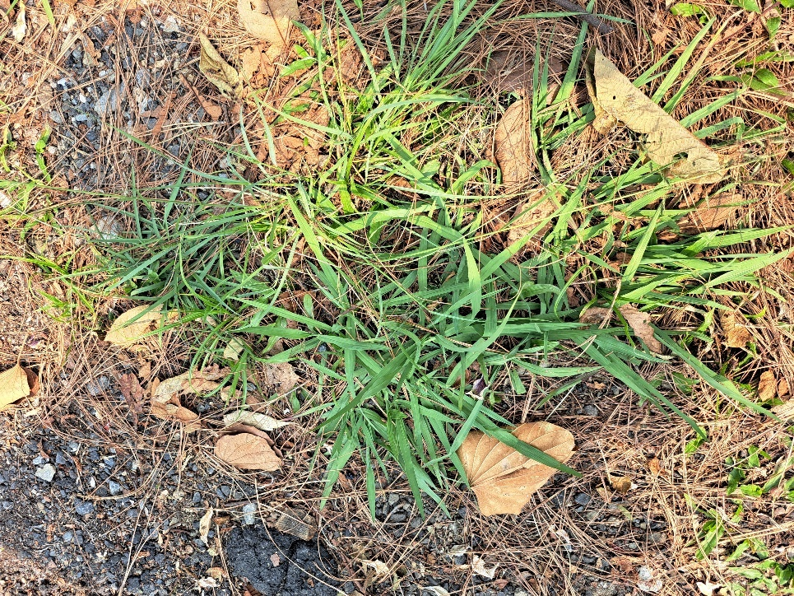

Crofton weed/Mexican devil

Banmara

# Ageratina Adenophora

Asteraceae

Herb

Crofton weed is a herbaceous perennial plant that grows as a shrub-like or herbaceous shrub, reaching heights of up to 2 meters. The flowers are small, white to pale lavender, and clustered in dense inflorescences at the ends of branches. Similarly, the leaves are opposite, lance-shaped to elliptical, and have serrated margins. They are dark green on the upper side and lighter green on the underside.

1. In traditional medicine, some parts of crofton weed have been used to treat ailments such as respiratory problems, skin conditions, and fever.
2. Like many invasive plants, crofton weed can grow quickly and densely. In some cases, this rapid growth can help stabilize soil and prevent erosion in disturbed areas.

Crofton weed (Ageratina adenophora) has a unique method of reproduction known as apomixis. Apomixis is a form of asexual reproduction where seeds are produced without the need for fertilization. This means that crofton weed can produce seeds without the involvement of pollination or sexual reproduction, allowing it to rapidly spread and establish new populations.

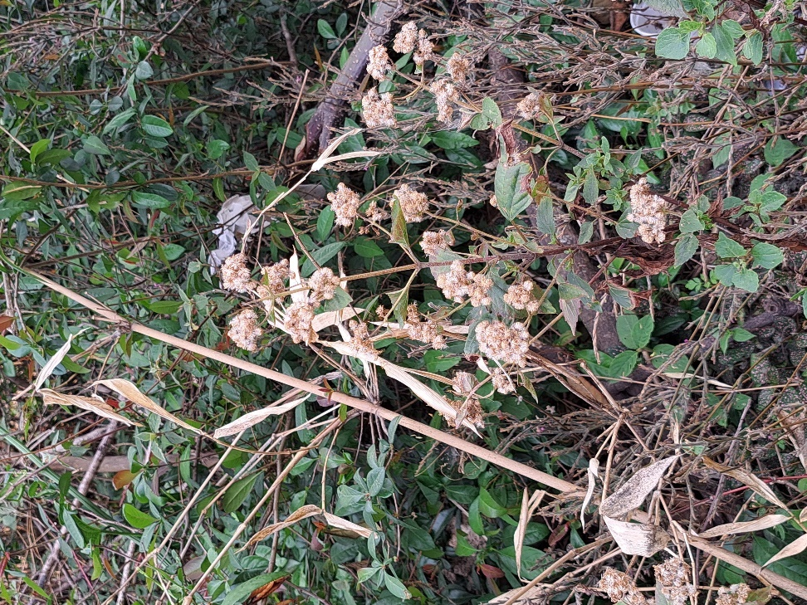

Coriander

Dhaniya

# Coriandrum sativum

Apiaceae

Herb

The flowers of coriander are small and white or pale pink in color. They are arranged in umbels, which are umbrella-like clusters. Similarly, Coriander has flat, parsley-like leaves that are feathery and divided into smaller segments. The leaves are bright green and have a distinctive aroma. Coriander leaves have a fresh, slightly citrusy flavor that adds a unique taste to dishes. The seeds have a warmer, nuttier flavor that is often used in spice blends. Likewise, the plant has slender, branched stems that can grow up to about 20-60 cm in height.

1. Coriander is a staple herb in many cuisines around the world, including Indian, Middle Eastern, Mexican, Thai, and Mediterranean cuisines. Both the leaves and the seeds are used to add flavor and aroma to a wide range of dishes.
2. Coriander is often used as a natural remedy to help with digestion and alleviate bloating, gas, and indigestion. It is believed to have carminative properties that can help soothe the digestive tract.
3. Coriander oil has been used historically as a natural preservative for pickling and preserving foods due to their antimicrobial properties.

Two-in-One Herb: Coriander is a unique herb in that it is often used in two distinct forms with different names and flavors. The fresh, green leaves of the coriander plant are commonly known as "cilantro", while the dried seeds of the same plant are referred to as "coriander seeds." What's interesting is that cilantro and coriander seeds have distinctly different flavors. Cilantro leaves have a fresh, citrusy taste, while coriander seeds have a warm, nutty, and slightly spicy flavor.

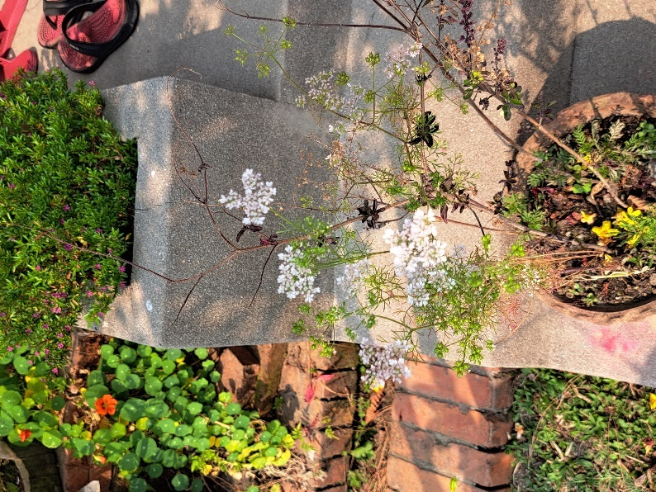

Coppertone sedum

# Sedum nussbaumerianum

Crassulaceae

Herb

The leaves of Coppertone Sedum are one of its most striking features. They are thick, fleshy, and succulent, designed to store water. The leaves are oval or teardrop-shaped, about 1-2 inches long, and have a unique coppery-red to orange hue. Similarly, Coppertone Sedum produces small star-shaped flowers that typically appear in clusters at the tips of the stems.

1. Coppertone Sedum is primarily grown for its ornamental value. Its unique coppery foliage and trailing growth make it a popular choice for adding color and texture to succulent gardens, rock gardens, container plantings, and hanging baskets.
2. Due to its spreading growth habit, Coppertone Sedum can help control erosion on slopes and banks. Its mat-forming tendency helps stabilize soil and prevent erosion in certain landscapes.

Coppertone Sedum not only adds beauty to your garden but can also play a role similar to that of a living mulch. Its trailing growth habit and thick foliage can help suppress weed growth and retain moisture in the soil, providing a natural form of ground cover that contributes to the health of the ecosystem. This "living mulch" effect can be particularly useful in areas where maintaining soil moisture and reducing weed competition are important considerations.

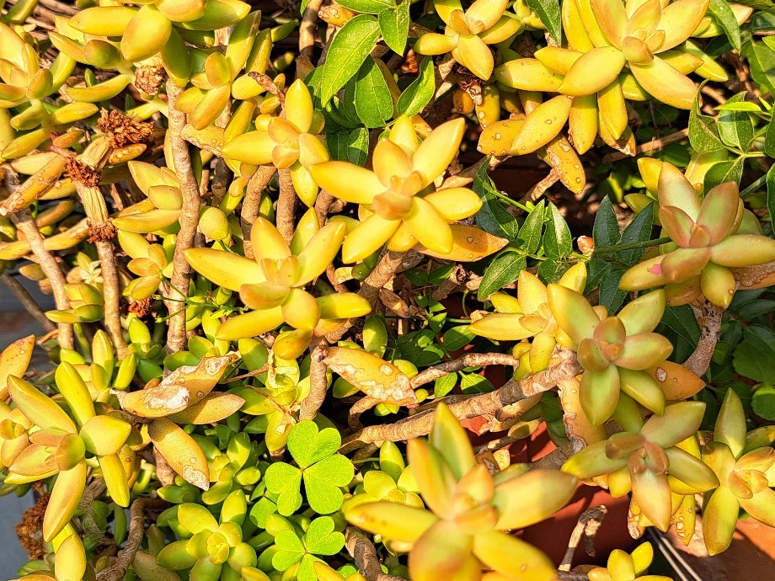

Common Jasmine

Chameli

# Jasminum officinale

Oleaceae

Shrub

Depending on growing conditions, common jasmine can grow to be anywhere from 3 to 7.5 meters tall. The leaves of common jasmine are typically dark green and glossy. They are composed of multiple small, oval-shaped leaflets arranged opposite each other along a central stem. Similarly, Common jasmine is renowned for its fragrant, white, star-shaped flowers. These flowers are small, with five to nine petals, and they usually appear in clusters or cymes.

1. The essential oil extracted from jasmine flowers is used in aromatherapy for its calming and uplifting effects. The scent of jasmine is believed to promote relaxation, reduce stress, and improve mood.
2. Common jasmine is widely cultivated as an ornamental plant in gardens, parks, and landscapes. Its beautiful flowers and climbing growth habit make it a popular choice for adding visual appeal to outdoor spaces.
3. Jasmine flowers are sometimes used to flavor teas and other beverages. Jasmine tea, for example, is made by combining tea leaves with jasmine flowers, resulting in a delicately scented and flavorful drink.

One of the fascinating aspects of common jasmine is that its flowers release their most potent and enchanting fragrance during the evening and nighttime hours. This phenomenon is often referred to as "nocturnal blooming." The fragrance is most intense after sunset and tends to gradually diminish as the sun rises. This adaptation is thought to attract nocturnal pollinators like moths, which are more active during the darker hours. So, if you have common jasmine in your garden, taking an evening stroll nearby might reward you with its captivating aroma.



Common fig

# Ficus carica

Moraceae

Tree

The fig fruit is the most distinctive feature of the common fig tree. Figs are actually a unique type of "multiple fruit" called a syconium, where multiple flowers develop into a single fruit structure. Similarly, fig trees can vary in size depending on their growing conditions, but they generally grow to be medium-sized trees. Mature fig trees can reach heights of 3 to 9 meters and have a spread that's somewhat proportional to their height. The flowers of the fig tree are actually located inside the fig fruit and are not easily visible. They are pollinated by tiny wasps that enter the fig's opening.

1. The most notable and widely recognized use of the common fig is its delicious and nutritious fruit. Figs are consumed fresh, dried, or in various culinary preparations.
2. Figs are a good source of dietary fiber, vitamins (such as vitamin A, vitamin K, and several B vitamins), minerals (such as potassium and magnesium), and antioxidants.
3. Figs can be made into preserves, jams, and chutneys. These products are used as spreads, condiments, and flavorings for various dishes.
4. Dried figs are a popular snack and are often used in baking, confections, and trail mixes. They have a concentrated sweetness and chewy texture.

The common fig has a unique way of flowering that is not immediately visible from the outside. The fig's flowers are actually located inside the fruit, hidden from view. The fig fruit, often referred to as a "syconium," develops from multiple tiny flowers that are situated on the inner surface of the fig. This means that when you bite into a fig, you're also consuming the flowers! The fig's pollination process involves a special relationship with a tiny wasp, which enters the fig to lay its eggs and help pollinate the flowers.

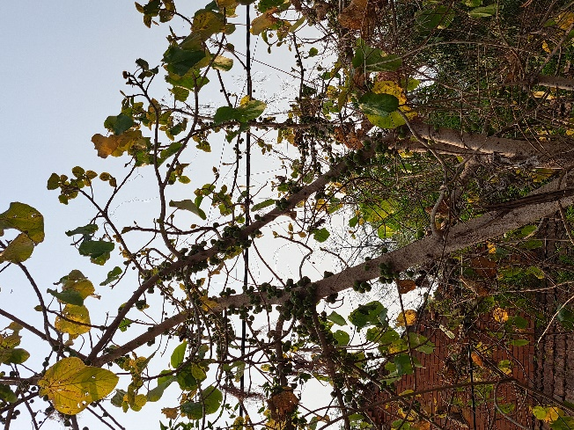

Common Bean

Simi

# Phaseolus vulgaris

Fabaceae/legume

Herb/vine

Usually, common beans can reach various heights according to the growing conditions. It grows like a vine and grows according to the height of the support it’s on. The leaves of the common bean plant are typically green, alternate and is composed of three leaflets, giving the leaves a trifoliate appearance. Similarly, the stems of common bean plants are herbaceous, meaning they are not woody like the stems of trees or shrubs. They are typically climbing or twining in nature, which allows the plant to climb on structures or nearby plants for support.

1. Common beans are a rich source of essential nutrients such as protein, dietary fiber, complex carbohydrates, vitamins (including B vitamins), and minerals.
2. Common beans are incredibly versatile in the kitchen. They can be cooked, boiled, or used in a wide variety of dishes, such as soups, stews, salads, curries, and more.

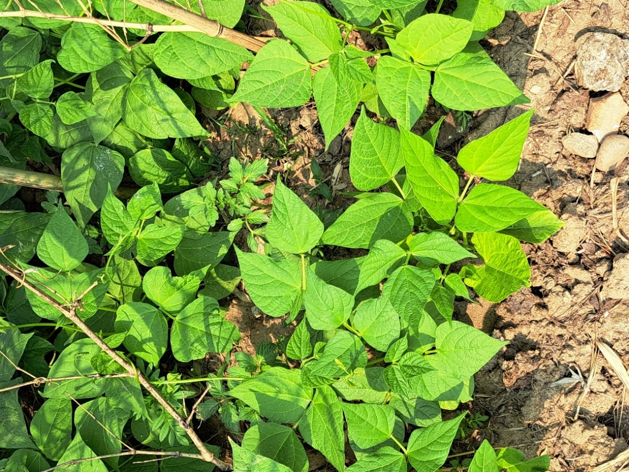

Chives

# Allium schoenoprasum

Amaryllidaceae

Herb

Chive leaves are slender, long, and hollow. They resemble thin, grass-like blades and are typically bright green in color. The leaves grow from a central base and can reach lengths of around 15 to 30 centimeters. Similarly, Chives produce small, round, purple or pink flowers in clusters at the top of long stems. These flower clusters can add an attractive ornamental element to the plant, and they are also edible. Chives are part of the Allium family, which includes onions and garlic. As a result, they have a mild onion flavor and a subtle, pleasant aroma.

1. Chives are primarily used as a flavorful herb in cooking. They have a mild onion flavor that adds a fresh and subtle onion taste to dishes without overpowering other flavors. Chopped chives are often used as a garnish for soups, salads, omelets, baked potatoes, and various other dishes.
2. Chives are a low-calorie herb that adds a burst of flavor to dishes without significantly impacting caloric intake. They also contain vitamins, minerals, and antioxidants, making them a healthful addition to the diet.

Chives are believed to have been cultivated for over 5,000 years! They have a long history of use in various cultures around the world. Ancient Chinese, Egyptian, and Roman civilizations are known to have used chives both for culinary purposes and for their perceived medicinal benefits. Chives' popularity continued to grow over the centuries, and they eventually made their way into modern cuisine. Their delicate onion flavor makes them a versatile herb that can be used in a wide range of dishes, from soups and salads to sauces and omelets.

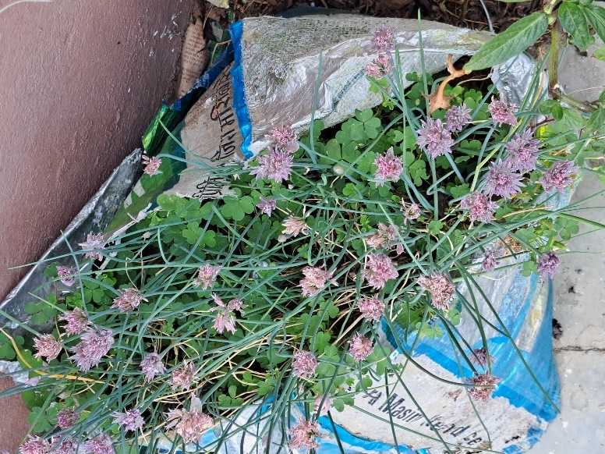

Canna Lilly/Indian Shot

# Canna indica

Cannaceae

Herb

Canna lilies are known for their vibrant and showy flowers. The flower colors can range from shades of red, orange, yellow, and pink to more subdued hues. Similarly, the leaves of it are large, broad, and typically lance-shaped. They can range in color from green to variegated varieties with stripes or spots. The leaves often have a tropical appearance, resembling those of banana plants. Likewise, the stems are sturdy and can reach varying heights, depending on the specific cultivar and growing conditions.

1. One of the primary uses of Canna indica is as an ornamental plant. Its large, colorful flowers and impressive foliage make it a popular choice for landscaping, gardens, and outdoor decor.
2. The dense root system of this plant can help stabilize soil and prevent erosion in areas prone to erosion, such as along water bodies and slopes.
3. While not commonly consumed, in some cultures, young shoots, flower buds, and even rhizomes of certain varieties of it have been used as food, either cooked or processed to remove bitterness.

The name "Indian Shot" is derived from the plant's hard, round seeds. These seeds are about the size of marbles and are extremely hard. In the past, they were sometimes used as makeshift projectiles in some regions, particularly in the Caribbean and Central America. The seeds were loaded into slingshots or blowpipes and used as ammunition, earning them the name "Indian Shot."

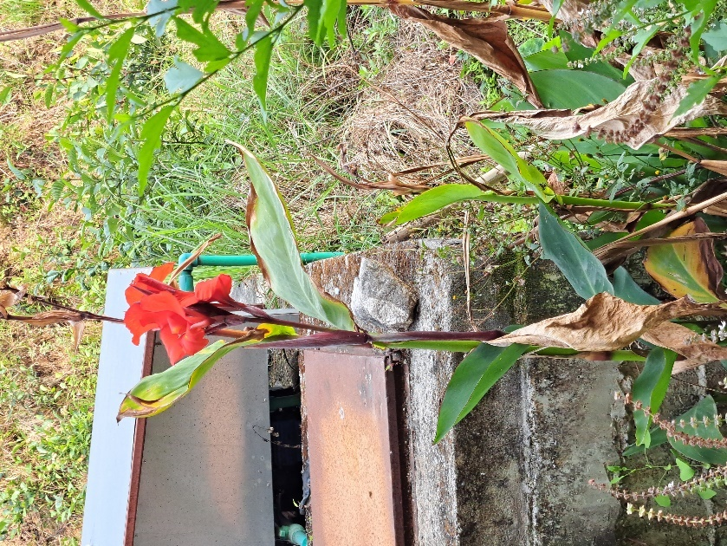

Broadleaf wood sorrel

# Oxalis latifolia

Oxalidaceae

Herb

The leaves of Broadleaf Wood Sorrel are clover-like, consisting of three heart-shaped leaflets that are usually broad and distinctive. The leaves often have a bright green color and can sometimes have purple markings on the undersides. Similarly, the stems of the plant are soft and non-woody, typical of herbaceous plants. They are often slender and may be slightly reddish in color. Likewise, the flowers of Broadleaf Wood Sorrel are small and delicate, usually with five petals. They can be white, yellow, or pink, depending on the specific variety.

1. One of the notable uses of Broadleaf Wood Sorrel is as an edible plant. The leaves and stems have a tart, citrus-like flavor due to their oxalic acid content. In moderation, they can be consumed fresh in salads, used as a garnish, or even added to dishes for a touch of tanginess.

Some people refer to this plant as the "Lucky Leaf" or "Good Luck Plant" due to its resemblance to a four-leaf clover. While true four-leaf clovers are considered symbols of luck, the leaves of Broadleaf Wood Sorrel can sometimes have three leaflets that are heart-shaped, which can resemble a four-leaf clover at a quick glance. This similarity has led to its association with good fortune in some cultures or among those who enjoy finding rare and lucky plants.

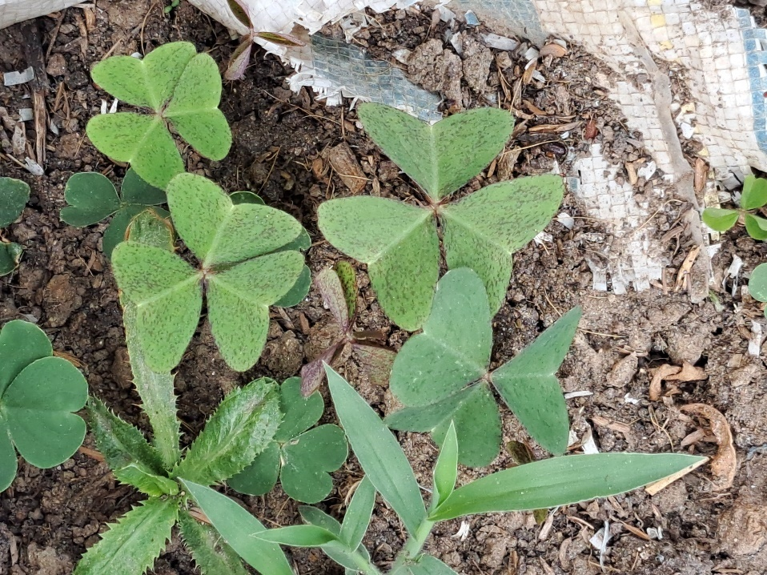

Paper flower

# Bougainvillea

Nyctaginaceae/ Four O'Clock family

Shrub

One of the most prominent features of Bougainvillea is its colorful bracts. These are modified leaves that surround the small, inconspicuous flowers. The bracts are responsible for the plant's vibrant and striking appearance. The true flowers of Bougainvillea are small and white, often located in the center of the colorful bracts. Similarly, the leaves of this plant are generally small to medium-sized, simple, and oval in shape. The leaves are typically green, but their color can vary slightly depending on the variety and growing conditions.

1. One of the primary uses of Bougainvillea is as an ornamental plant. Its vibrant and showy bracts make it a popular choice for gardens, landscapes, and outdoor decor.
2. When grown as a climbing plant, Bougainvillea can serve as an effective privacy screen by covering walls or fences with its dense foliage and colorful bracts.
3. In some regions, the bracts of Bougainvillea have been used to produce natural dyes for textiles and crafts.

The colorful "flowers" that we associate with Bougainvillea are not actually its true flowers. The vibrant, petal-like structures that we see are called bracts, and they surround the small, inconspicuous true flowers. These bracts are modified leaves that serve to attract pollinators to the true flowers, which are nestled within. The vivid bracts are what give Bougainvillea its stunning and showy appearance, and they come in various colors, making the plant a favorite for adding splashes of color to gardens and landscapes.

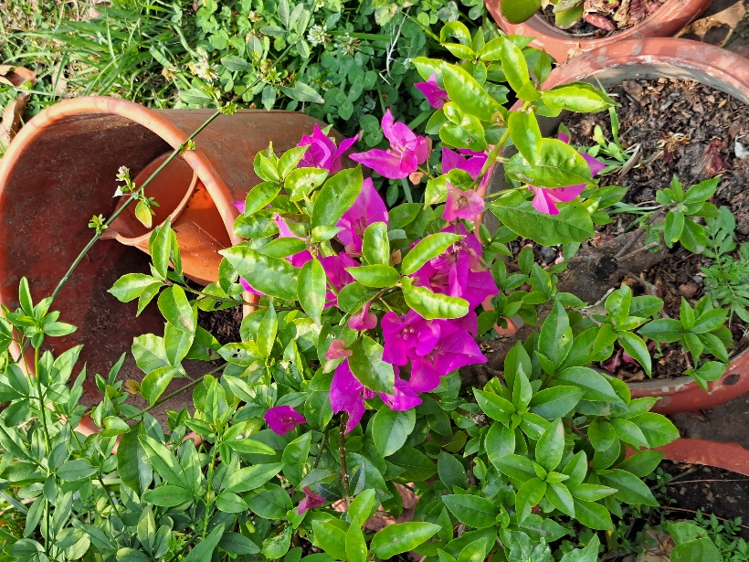

Bottlebrush

# Callistemon

Myrtaceae

Tree

The most distinctive feature of bottlebrush plants is their cylindrical flower spikes that resemble a bottle brush. These spikes are composed of numerous small individual flowers tightly packed together. The individual flowers on the spikes are small and tubular in shape. Bottlebrush plants typically have evergreen leaves that are narrow, lance-shaped, and arranged alternately along the stems. The leaves are usually dark green and glossy, contributing to the plant's attractive foliage. Bottlebrush trees can range in size from a few feet to several meters in height.

1. One of the primary uses of bottlebrush plants is as ornamental additions to gardens and landscapes. Their unique cylindrical flower spikes and attractive foliage make them popular choices for adding color and visual interest to outdoor spaces.
2. The nectar-rich flowers of bottlebrush plants attract various pollinators, including bees, butterflies, and nectar-feeding birds. This makes them valuable contributors to local ecosystems and biodiversity.

The name "bottlebrush" is derived from the plant's unique flower spikes, which resemble the shape of a traditional bottle-cleaning brush. The cylindrical flower spikes with numerous small flowers clustered around the stem create a brush-like appearance, leading to the common name "bottlebrush." This distinctive feature not only adds to the plant's visual appeal but also gives it a memorable and fitting name that reflects its appearance in nature.

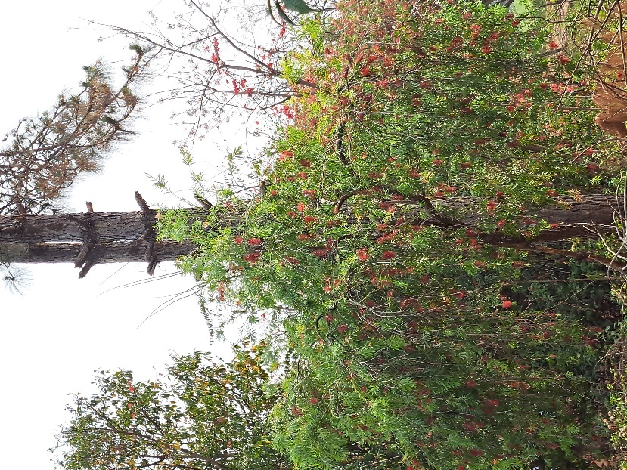

Aloe vera

Ghew Kumari

# Aloe barbadensis miller

Asphodelaceae

Shrub

Aloe vera typically grows in a rosette form, with thick, fleshy leaves clustered around a central point. The leaves emerge from a basal stem or base. The leaves are succulent, meaning they are thick and fleshy, designed to store water. Similarly, Aloe vera has a shallow root system designed to quickly absorb water after rain or irrigation. This system helps the plant take advantage of infrequent water availability.

1. Aloe vera gel is renowned for its soothing and moisturizing properties. It's used to treat various skin issues, such as sunburn, minor burns, rashes, cuts, and insect bites. It can also help alleviate dry skin.
2. The gel of Aloe vera contains compounds that are believed to accelerate wound healing. It can be used to aid in the healing process of minor wounds, cuts, and abrasions.
3. Aloe vera gel is used in hair care products to promote hair health, reduce dandruff, soothe an itchy scalp, and add shine to hair.
4. Aloe vera juice, extracted from the inner leaf, is consumed for potential digestive benefits. It's believed to support digestion, alleviate constipation, and promote gut health.

NASA has included Aloe vera in its list of air-purifying plants. Aloe vera is not only known for its skincare and healing properties but also for its ability to help improve indoor air quality. It's effective at removing pollutants like formaldehyde and benzene from the air, making it a natural air purifier. So, having an Aloe vera plant in your home not only offers potential skincare benefits but can also contribute to a healthier indoor environment!

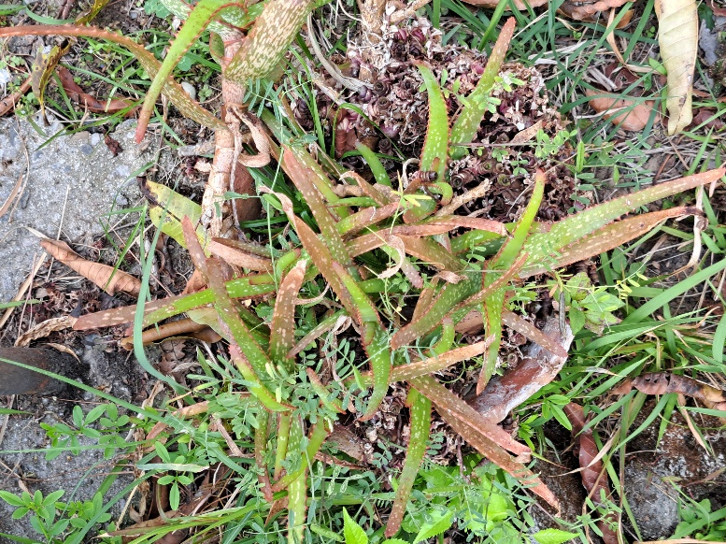

Century plant

# Agave americana

Asparagaceae

Herb

The leaves are the most prominent feature of the plant. They are large, broad, and lance-shaped, with sharp points at the tips. The leaves of Agave americana are often bluish-green or grayish-green and, the leaf margins are serrated with teeth or small spines along the edges. The leaf margins in some species are of light-yellow color.

1. Agave americana is widely cultivated as an ornamental plant in gardens and landscapes due to its striking and architectural appearance. Its large rosette of spiky leaves adds unique visual interest to outdoor spaces.
2. The fibers extracted from the leaves of Agave americana are used to make ropes, mats, baskets, and various woven items. The strong and durable fibers made it a valuable resource for practical purposes.

Despite its common name "Century Plant," Agave americana does not actually take a century to flower. While it's a slow-growing plant, it typically takes between 10 to 30 years for it to bloom, depending on growing conditions. When it does flower, it sends up an impressive tall stalk that can reach up to 20 feet (6 meters) or more, showcasing a spectacular display of yellow flowers. After this grand display, the main plant dies, having completed its life cycle. However, by this time, it usually has produced several "pups" or offsets, which will continue to grow and eventually flower in the future.

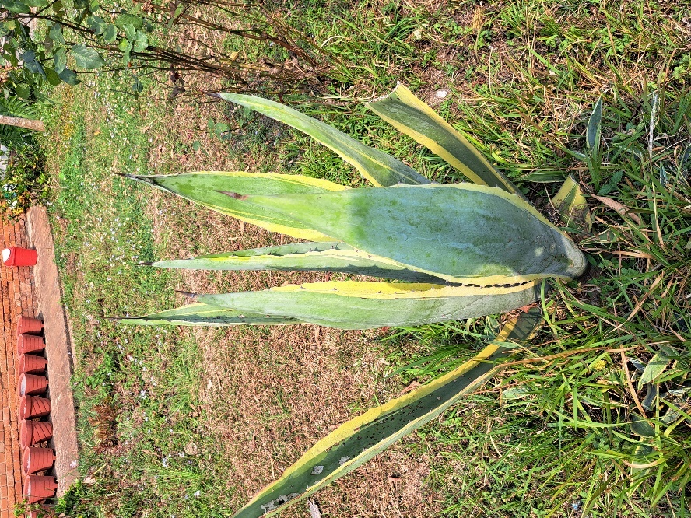

African marigold

# Tagetes erecta

Asteraceae

Herb

African marigolds are relatively tall annual plants, often growing to heights of 30 to 90 centimeters or even taller, depending on the variety and growing conditions. Similarly, the leaves of African marigolds are dark green, pinnate (feather-like), and arranged alternately along the stems. They can vary in size and shape, with serrated edges. African marigolds have large, showy flower heads and the flowers come in a range of vibrant colors, including shades of yellow, orange, and sometimes red.

1. African marigolds are widely cultivated as ornamental plants in gardens, landscapes, and containers due to their vibrant and large flower heads. They add a splash of color and beauty to outdoor spaces.
2. The bright and colorful blooms of African marigolds are often used in floral arrangements for various occasions, including weddings, festivals, and events.
3. The marigold is one of the most well-known insect-repelling plants and with good reason — they have a scent that will keep pests like mosquitoes, nematodes like cabbage worms, and other pests away.
4. The petals of some marigold varieties can be used to extract natural dyes for textiles and crafts.

The vibrant flowers of African marigolds aren't just visually appealing—they also have a culinary use! While not as commonly used as other edible flowers, the petals of African marigolds are considered safe to eat and can be used to add a touch of color and flavor to various dishes. The petals have a slightly citrusy and tangy flavor, making them a unique and decorative addition to salads, desserts, and even beverages. Just remember to use them sparingly and ensure that the flowers you use are grown without pesticides or chemicals.

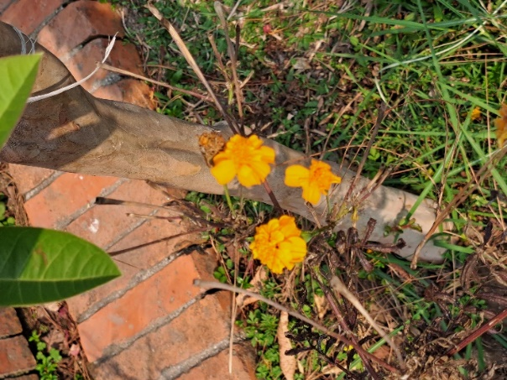

Block 8🡪

Tailed Maidenhair

# Adiantum caudatum

Pteridaceae

Shrub

The leaves of Adiantum caudatum are finely divided and feathery in appearance. They are composed of numerous small leaflets that give the plant a delicate look. The black or dark-colored stems of this fern are slender and rough, growing upright. Similarly, these plants are typically a small to medium-sized fern, reaching a height of about 30 to 60 cm.

1. Adiantum caudatum is primarily grown for its ornamental value. It is often used in gardens, landscapes, and indoor settings to add a touch of beauty and charm.
2. It is often used in gardens, landscapes, and indoor settings to add a touch of beauty and charm.
3. Tailed Maidenhair Ferns like other house plants, can contribute to indoor air purification by removing certain toxins and increasing humidity.

A fun fact about the Tailed Maidenhair Fern, is that it is often referred to as the "Walking Maidenhair Fern." The plant reproduces by dropping spores from the undersides of its fronds. When the spores are released and land on suitable growing conditions, new ferns can sprout. As a result, over time, this fern can seemingly "walk" and spread to new locations as the spores establish themselves and grow into new plants.

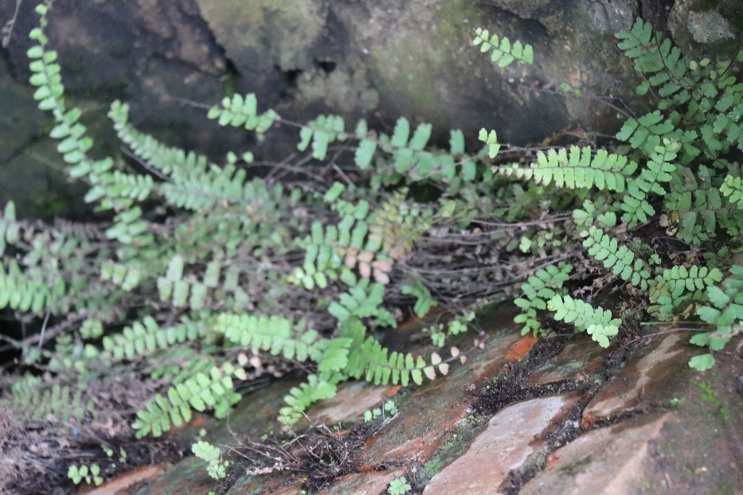

Field Sowthistle

# Sonchus arvensis

Daisy family

Herb

Field Sowthistle produces bright yellow, daisy-like flowers. The flower heads are typically 2.5 to 5 cm in diameter. The stem of Sonchus arvensis is erect, usually hairless, and can grow to varying heights, ranging from a few inches to several feet, depending on environmental conditions. The leaves of Field Sowthistle are typically lobed, lance-shaped and are generally green and sometimes covered with fine hairs.

1. Some people have consumed young leaves and stems of Sonchus arvensis as a leafy green vegetable, particularly in times of food scarcity. When properly prepared, these parts can be edible and a source of nutrition.
2. As a deep-rooted plant, Field Sowthistle can help improve soil structure and nutrient cycling in some cases.

A fun fact about Sonchus arvensis is that it's sometimes referred to as "Hare's Colwort" because of the belief that hares and rabbits are particularly fond of this plant and often consume it as part of their diet.

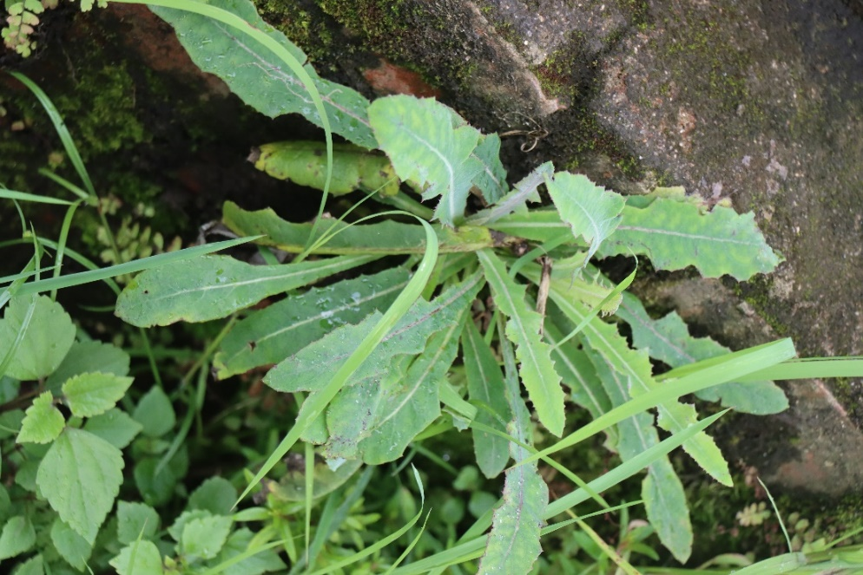

Tropical Soda Apple

Kaande Bhantaa

# Solanum viarum

Solanaceae/Nightshade

Shrub

It is a woody shrub or small tree that can grow up to several meters in height. It typically has a multi-branched, bushy growth form. The leaves are alternately arranged along the stems and are typically large (10 to 20 cm). Similarly, the flowers of Solanum viarum are white to pale yellow in color and have five lobes. Likewise, the fruit is a round to slightly oval berry, initially green and turning yellow when ripe and contains numerous seeds.

Solanium viarum is not edible and is considered toxic to humans and livestock. There are generally no benefits of this plant.

Efforts to control Tropical Soda Apple have led to innovative uses for the plant. In some regions, such as Florida, researchers have explored the use of biological control agents, such as specific insects that feed on the weed. These insects have been introduced to help manage and reduce the population of Tropical Soda Apple.

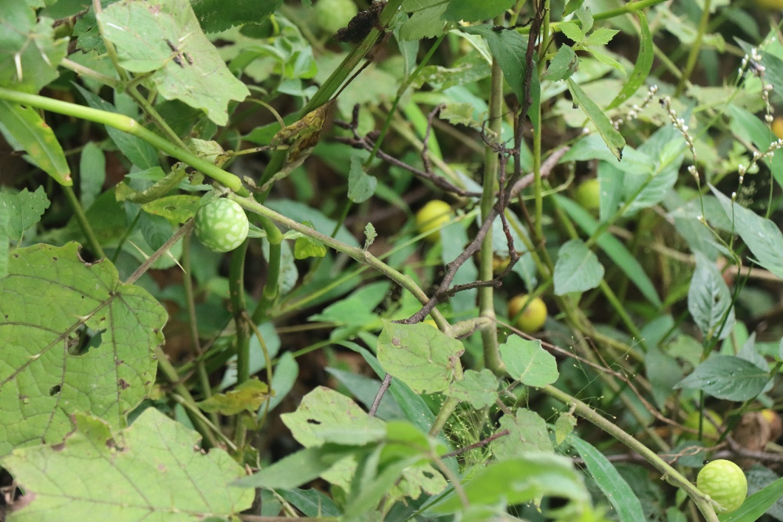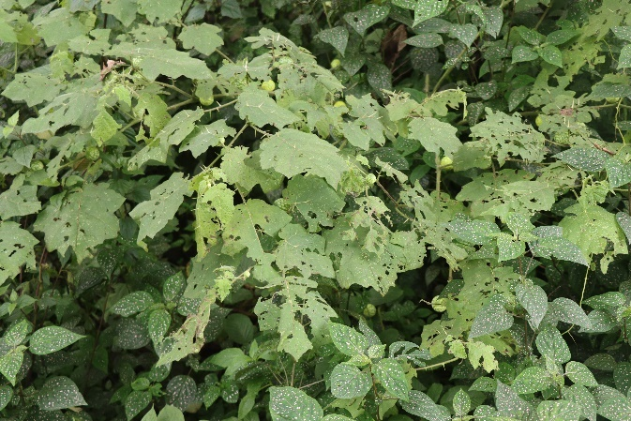

Tree tomato

Rukh Tamatar

# Solanum betaceum

Solanaceae/Nightshade

Tree

The plant grows as a small tree, reaching heights of 3 to 4.5 meters. It has a central trunk with branches and a canopy of leaves. Tree tomato fruits are typically oval or egg-shaped and can vary in size, typically measuring about 5 to 10 cm in length and are mostly red in color. Similarly, the tree tomato plant has large, simple leaves that are dark green and smooth.

1. Tree tomatoes are primarily cultivated for their fruit, which is consumed fresh or used in various culinary applications.
2. Its fruit can be used in a variety of dishes and recipes. It is often used to make chutneys, salsas, jams, and preserves.
3. The fruit can be juiced to make refreshing beverages, smoothies, and cocktails. The juice can also be used as a base for sauces or salad dressings.

Tree tomato (tamarillo) is not related to the traditional tomato at all, despite sharing the word "tomato" in its name. Tamarillo is a member of the Solanum genus, like the tomato, but it belongs to a different species, Solanum betaceum. The name "tree tomato" is due to the fruit's somewhat tomato-like appearance and the fact that it grows on a tree-like plant.

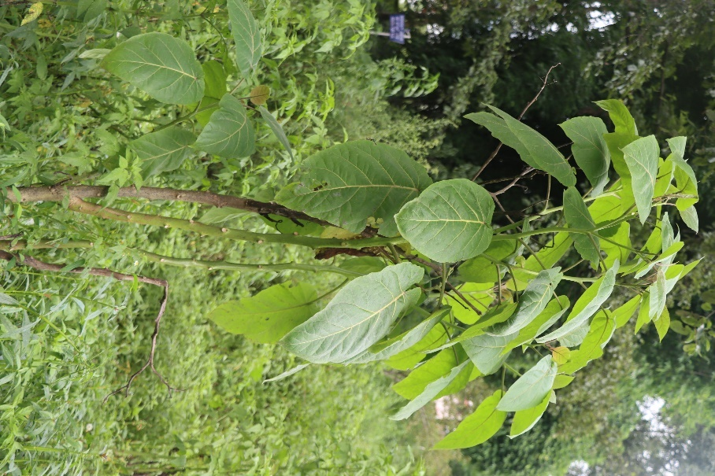

Palmgrass

# Setaria palmifolia

Poaceae

Setaria palmifolia is a large, herbaceous, clump-forming perennial grass. It can reach heights of up to 3 meters. The leaves of Setaria palmifolia are large and broad, resembling palm fronds. They are typically dark green in color and can grow to be around 60 cm long. Similarly, the stems of Setaria palmifolia are strong and can grow quite tall, with a tendency to arch gracefully under the weight of the leaves.

1. Setaria palmifolia is primarily grown as an ornamental plant for its attractive and tropical appearance. Its large, palm-like leaves and distinctive, fountain-like inflorescences make it a popular choice for landscaping.
2. Setaria palmifolia can be employed for erosion control, especially in areas prone to soil erosion along riverbanks and coastal regions.

Setaria palmifolia (Palm Grass or Fountain Grass) is not actually a palm but a grass species. Despite its common name and palm-like appearance, it belongs to the family Poaceae, making it a member of the grass family.

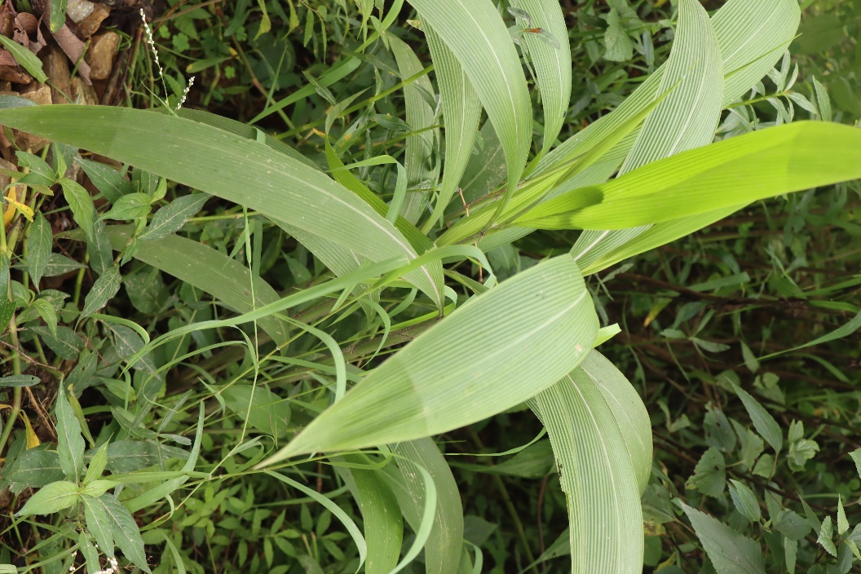

Yellow Himalayan Raspberry

# Rubus ellipticus

Aiselu

Rosaceae

Shrub

Rubus ellipticus has thorny stems and the leaves are elliptical in shape, green and serrated, with a glossy appearance. This plant produces white to pale pink flowers that are typically around 2-3 centimeters in diameter. These flowers have five petals and are usually arranged in clusters. Similarly, the fruits of Rubus ellipticus are yellow to golden in color, and they are somewhat similar in appearance to raspberries.

1. The primary use of Rubus ellipticus is its edible fruit. The yellow to golden berries produced by the plant are consumed by local people in the Himalayan region and are used to make jams, jellies, and desserts.
2. The growth habit of Rubus ellipticus, with its thorny thickets, can be beneficial in controlling soil erosion in certain areas.

A fun fact about Rubus ellipticus is that it's sometimes referred to as the "Himalayan giant raspberry" due to the relatively large size of its berries compared to other Rubus species.

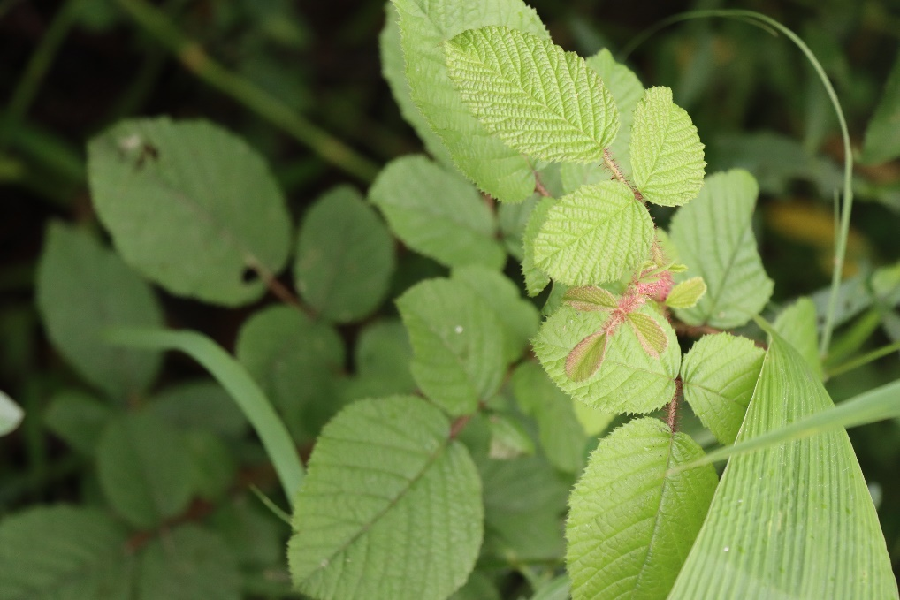

Shingle Oak

# Quercus imbricaria

Fagaceae

Tree

Shingle oaks are medium to large deciduous trees. They can reach heights of 15 to 24 meters. The leaves are simple and alternate, with a unique shape. They are elliptical, with smooth margins, and have a distinctive glossy green appearance and the bark of mature shingle oaks is light gray.

1. Shingle Oak wood is a durable and strong wood that has been used for various purposes, including furniture & carpentry.
2. It is also used to make shingles for covering roofs.

This plant gets its common name from the appearance of its bark, which resembles shingles or scales. The scaly ridges on the bark create a unique and visually interesting texture that distinguishes this oak species from others.

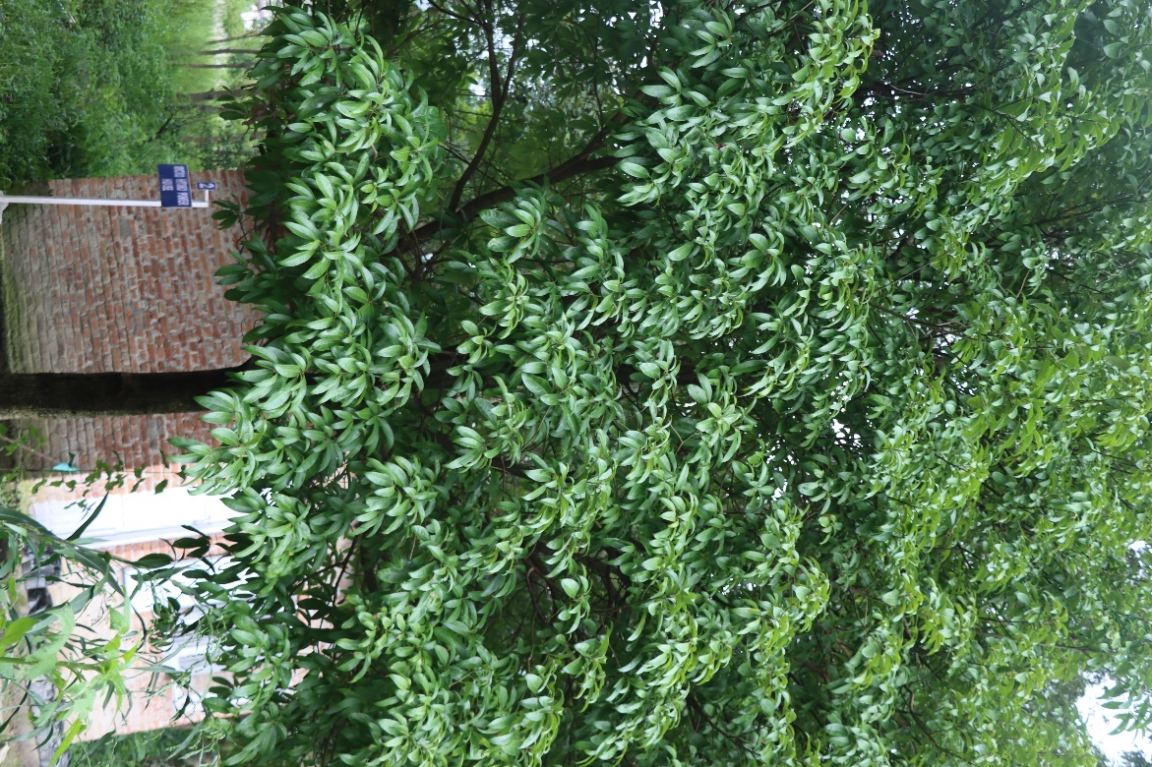

Nepal knotweed

# Persicaria nepalensis

Polygonaceae

Herb

The leaves of Persicaria nepalensis are lance-shaped and can be green to bluish green in color and often have a distinct dark in the center. The stems of this plant are slender and may exhibit reddish or purplish hues. Similarly, the nodes along the stems can be somewhat swollen.

1. Persicaria nepalensis is grown as an ornamental plant in gardens and landscapes for its aesthetic appeal. Its striking pink to reddish-pink flowers and colorful foliage add visual interest to outdoor spaces.

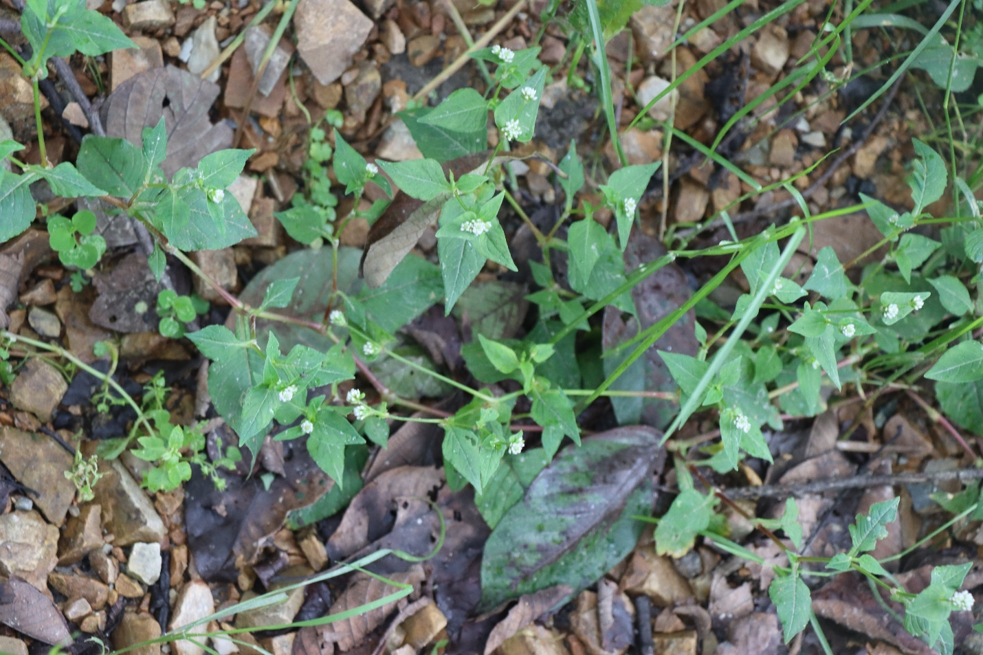

Pink Knotweed

# Persicaria capitata

Polygonaceae

Herb

The leaves of this plant are typically lance-shaped or elliptical and are often green, sometimes with purple spots which can measure 3-10 cm in length. The stems of Persicaria capitata are typically slender and green and slightly reddish in color. Similarly, the flowers are arranged in spike-like clusters and are pink to lavender in color.

1. Persicaria capitata is cultivated as an ornamental plant in gardens and landscapes. Its attractive pink to lavender flowers and colorful foliage add visual interest to outdoor spaces

A fun fact about Persicaria capitata, also known as pinkhead smartweed, is that it belongs to the Polygonaceae family, which is known for containing a variety of plants with distinctive jointed stems. These jointed stems are often called "nodes" and can be seen in many members of this family, including smartweeds.

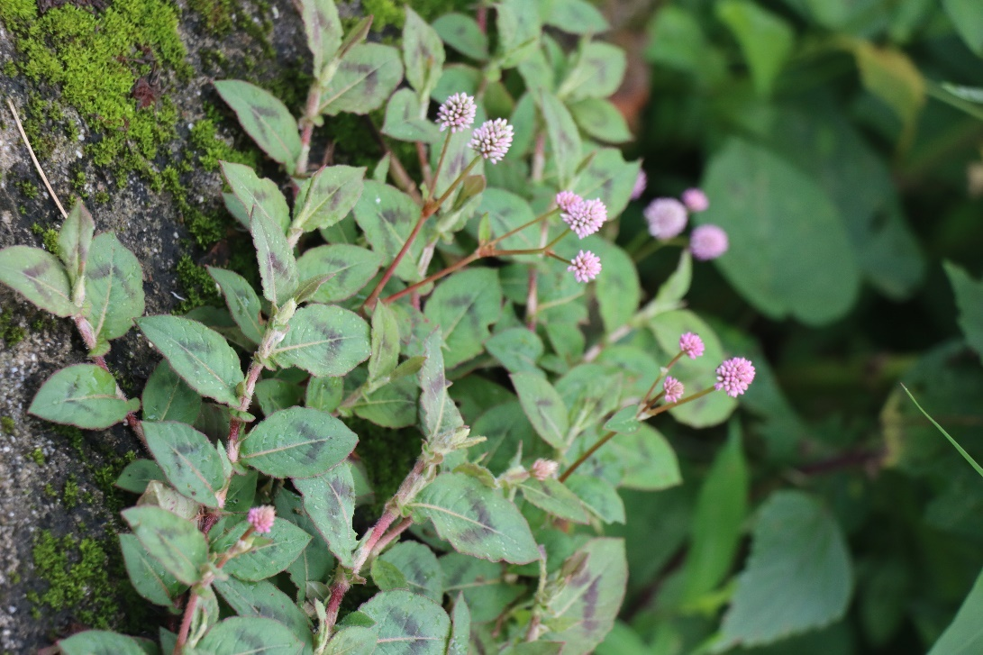

Common Lantana

# Lantana camara

Banmara

Verbenaceae

Shrub

Common lantana produces clusters of small, tubular flowers that are arranged in dense, globe-shaped heads. The flowers come in a variety of colors, including shades of red, orange, yellow, and pink. After the flowers fade, common lantana produces small, fleshy, and berry-like fruit. These fruits are typically dark purple to black when mature. Moreover, the leaves of common lantana are simple, opposite, and serrated.

1. Common lantana is commonly grown as an ornamental plant in gardens and landscapes. Its bright and colorful flowers, which come in various shades, make it an attractive addition to gardens.
2. In some regions, lantana is used for erosion control because of its ability to form dense thickets and stabilize soil.

After the flowers fade, this plant leaves small berries which gradually mature over time. Even though these berries look like edible fruits, they are toxic if ingested. So, consumption of its fruits should be avoided.

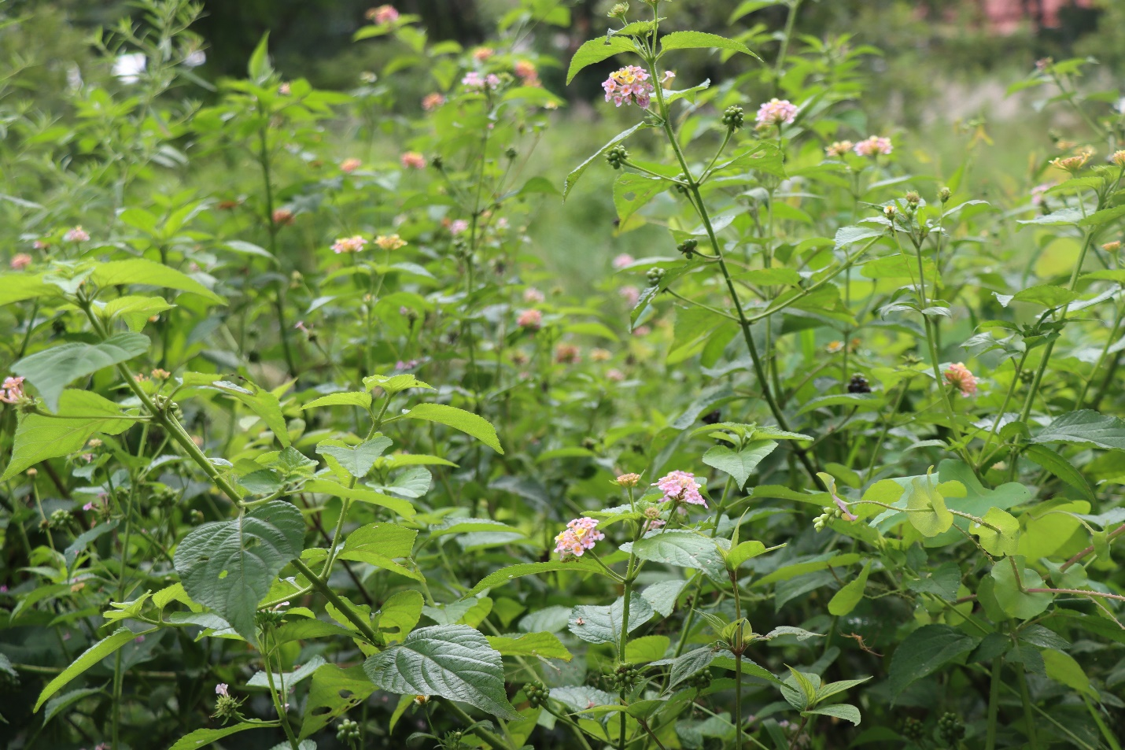

Crofton Weed

# Ageratina Adenophora

Kali jhar/Kalo Achhame

Asteraceae

Shrub

Crofton weed can grow as a tall shrub or small tree, reaching heights of up to 4 meters. The stems of Crofton weed are woody and can be either erect or sprawling. They are often green or reddish-brown and may become somewhat woody as the plant matures. Similarly, the plant produces clusters of small, white, or creamy white, tubular flowers. These flowers are somewhat cottony in appearance when they bloom.

When animals consume Crofton weed, they may exhibit symptoms such as:

1. Affected animals may show unusual and erratic behavior, including agitation and restlessness.
2. They become extremely sensitive to sunlight, leading to a condition known as "photosensitization."
3. Animals may develop skin problems, including sunburn-like lesions, scabbing, and peeling of the skin.

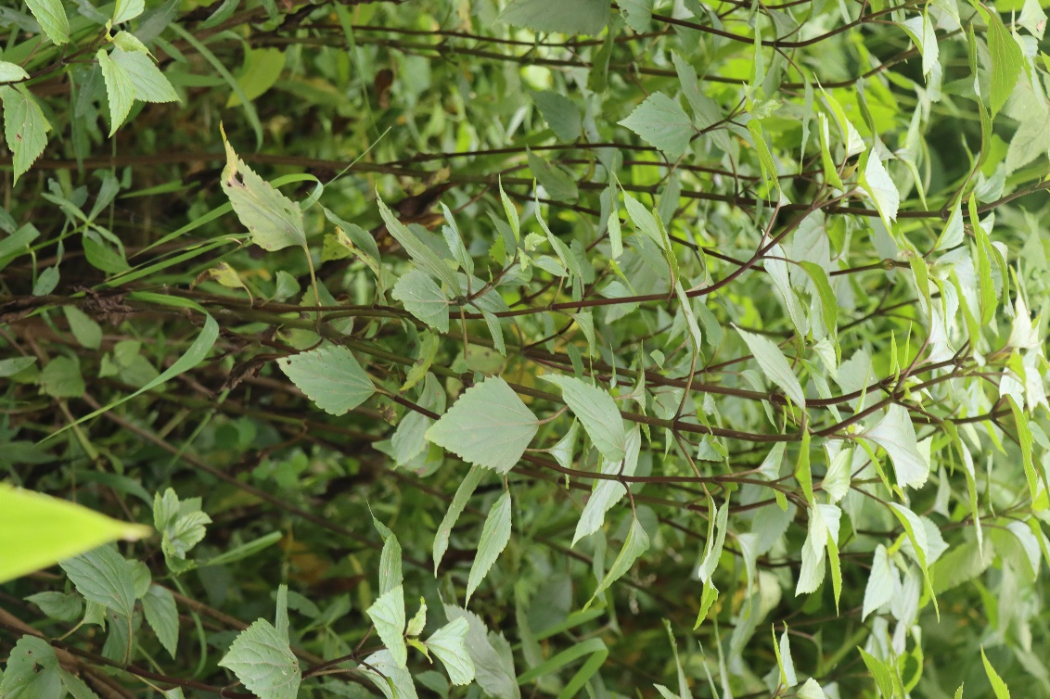

Billygoat Weed/Chick Weed

# Ageratum conyzoides

Gandhe(Seto)

Asteraceae

Herb

Ageratum conyzoides is a relatively low-growing plant, typically reaching heights of 20 to 80 centimeters. The leaves of it are opposite, simple, and typically egg-shaped. Similarly, the plant produces small, tubular, and fluffy-looking flowers. The flower heads are composed of numerous tiny individual florets that are typically white in color. Moreover, the stems of it are typically herbaceous, non-woody, and covered in fine hairs.

1. Ageratum conyzoides is sometimes cultivated as an ornamental plant. Its attractive lavender-blue or white flowers and bushy growth habit make it suitable for flower beds and borders.

Chick weed is not only an edible and nutritious plant but has a history of being used by early European settlers in North America as a food source. Chickweed is rich in vitamins and minerals, particularly vitamin C, and can be added to salads or used as a potherb. Its mild, fresh flavor and tender leaves make it a welcome addition to many dishes.

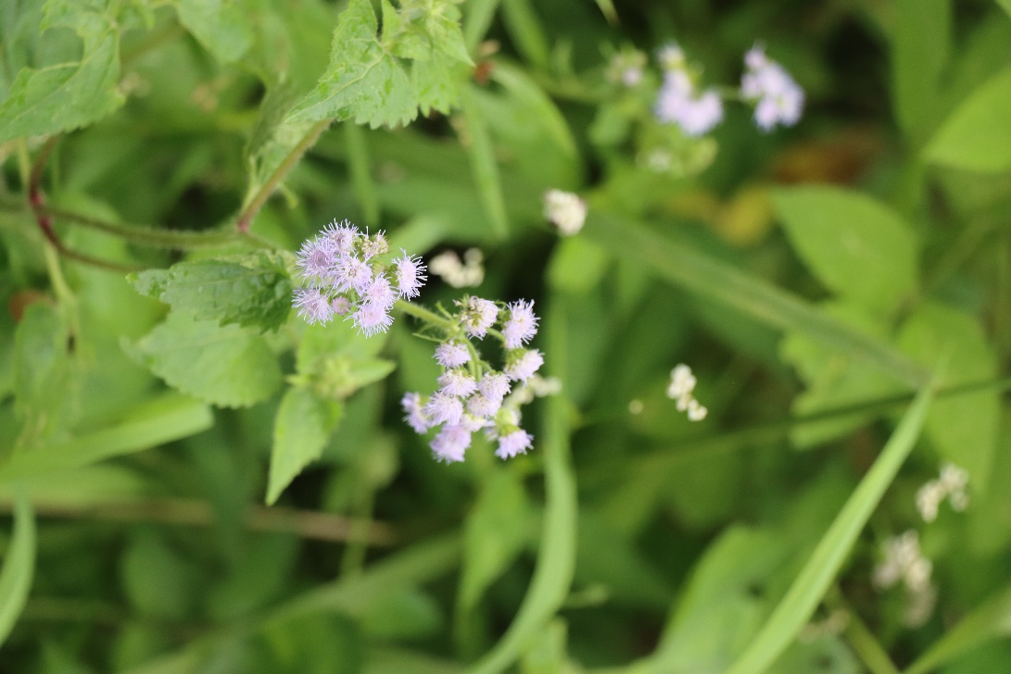

Alligator weed

# Alternanthera philoxeroides

Jalijamboo

Amaranthaceae

Herb

The leaves of alligator weed are opposite, lance-shaped, and usually measure 1 to 5 centimeters in length. Similarly, the stems of alligator weed are herbaceous and typically creeping or floating. They can root at the nodes, allowing the plant to spread and form dense mats on the water's surface. Also, Alligator weed has a fibrous root system and can also form roots at nodes along its stems.

1. Alligator weed can be utilized in some regions for erosion control. Its dense mats can prevent soil erosion in areas with slow-moving or still water bodies.

The plant's dense mats, which can float on the water's surface or cover the ground, are reminiscent of the back of an alligator or crocodile when seen from a distance. The name "alligator weed" is a reference to this distinctive appearance.

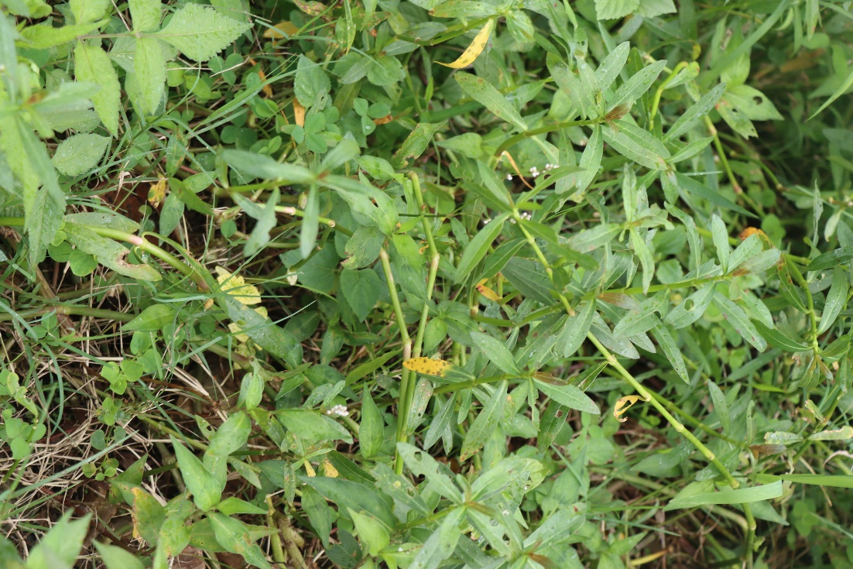

Nepalese Alder

# Alnus nepalensis

Utis

Betulaceae

Tree

Alnus nepalensis can grow to a height of 20 to 30 meters or more, depending on growing conditions. The leaves of it are simple, alternate, and typically serrated along the edges. They are broadly ovate to elliptical in shape, dark green in color, and can measure 5 to 15 centimeters in length. Similarly, the bark of the tree is smooth and grayish when young, but it becomes rougher and darker as the tree matures.

1. Nepal alder is known for its ability to improve soil fertility through a process known as nitrogen fixation. It forms a symbiotic relationship with nitrogen-fixing bacteria in its root nodules, which helps enrich the soil with nitrogen, benefiting neighboring plants.
2. The wood of Alnus nepalensis is used for construction of furniture and firewood.

It has the unique ability to form a symbiotic relationship with specific nitrogen-fixing bacteria known as actinomycetes. These actinomycetes are not commonly associated with nitrogen fixation in other plants. This special relationship allows the Nepal alder to thrive in nitrogen-poor soils, as it can take atmospheric nitrogen and convert it into a form that can be used by the plant, thereby enriching the soil with this essential nutrient.

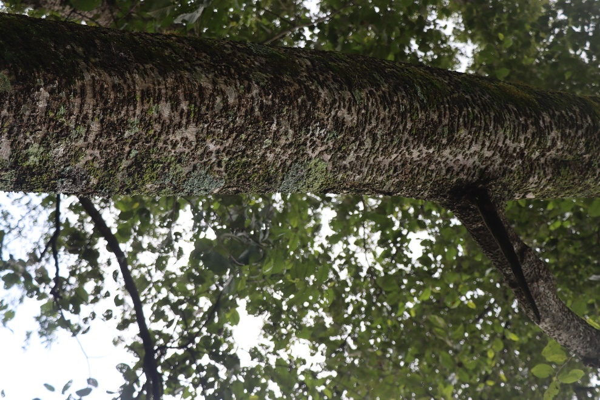

Bamboo

# Bambusa

Baas

Poaceae

Herb

Bamboo is tall, slender, and hollow stems, which are often referred to as culms. These culms can vary in size from small and slender to large and robust. Bamboo culms have nodes or joints that occur at regular intervals along their length. Leaves, branches, and roots typically emerge from these nodes. Similarly, Bamboo leaves are typically elongated and narrow, with various shapes and sizes depending on the bamboo species. The leaves are often arranged in a symmetrical pattern along the branches.

1. Bamboo is widely used as a construction material for housing, bridges, scaffolding, and various other structures. Its high strength, flexibility, and lightweight properties make it an excellent alternative to traditional building materials like wood.
2. Bamboo is commonly used to make furniture, such as chairs, tables, and shelves. It's also used for crafting a variety of decorative items and handicrafts.
3. Certain bamboo shoots are edible and a common ingredient in various Asian cuisines. They are known for their crunchy texture and ability to absorb flavors from other ingredients.
4. Bamboo can be used as a source of biofuel.
5. Bamboo fibers are used to make soft and breathable fabrics. Bamboo clothing is comfortable and has natural moisture-wicking and antibacterial properties.

Bamboo is the fastest-growing plant on Earth. Some bamboo species are known to grow incredibly quickly, with certain types capable of growing up to 3 feet (or about 91 centimeters) in just 24 hours under the right conditions. This astonishing growth rate is due to the rapid cell division and elongation in the bamboo culms.

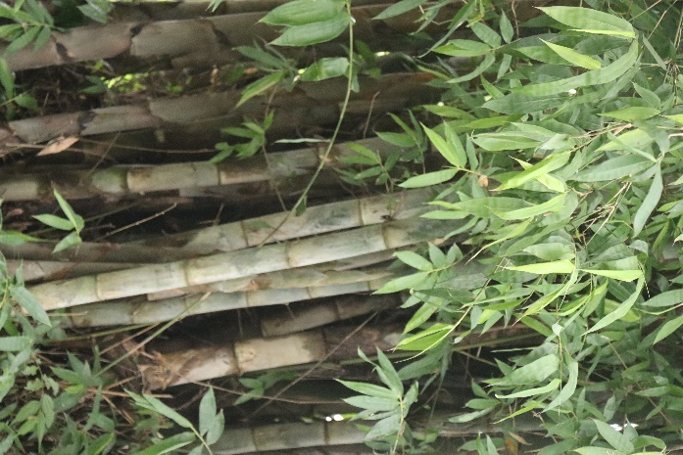

Black-jack

# Bidens Pilosa

Kaalo Kuro

Asteraceae

Herb

Bidens pilosa typically reaches a height of 1 to 2 meters, although it can vary depending on growing conditions. The leaves are opposite, pinnately compound, and have toothed margins. They are usually dark green, and each leaflet has a serrated edge. Similarly, the flowers of Bidens pilosa are small and daisy-like, with yellow or white ray florets and a central disk of darker disc florets.

1. In some cultures, the young leaves of Bidens pilosa are consumed as a leafy green vegetable. They can be added to soups, stews, or salads.
2. Some communities use the crushed leaves and stems of Bidens pilosa as a natural insect repellent due to their strong odor.

Bidens Pilosa has inspired the development of certain types of fasteners and adhesives. The seeds of it are covered in tiny barbs or spines that allow them to easily stick to clothing, animal fur, or any surface they come into contact with. This natural "hook-and-loop" mechanism has inspired the invention of Velcro, a well-known modern fastening system.

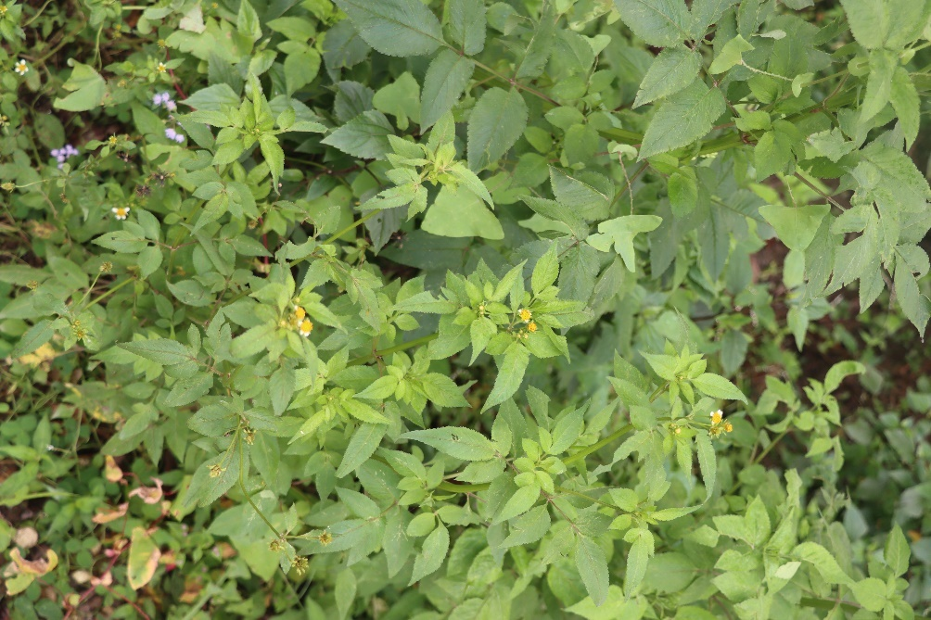

Lemon

# Citrus x limon

Kagati

Rutaceae

Tree

Lemon trees are relatively small to medium-sized trees, typically reaching heights of 3 to 6 meters. The leaves of the lemon tree are elliptical or ovate in shape, glossy, and dark green in color. They are typically 2 to 4 inches in length and have a fragrant aroma when crushed. Similarly, the lemon tree produces bright yellow, ellipsoidal or ovoid fruit known as lemons which have a sour or tart taste. Moreover, it produces white, fragrant, and waxy flowers with five petals.

1. Lemon juice and zest are widely used in cooking to add flavor and acidity to a variety of dishes, including soups, sauces, marinades, and salad dressings.
2. Lemons are a good source of vitamin C and provide essential nutrients and antioxidants.
3. Lemon essential oil is used in various perfumes, cleaning products, and scented candles.
4. The lemon juice and flavoring industry relies on lemon production for various products, including bottled lemon juice, lemon-flavored beverages, etc.

Lemon trees can live for a surprisingly long time, with some well-cared-for trees living for over a century. They are also quite hardy and can continue to produce fruit year-round, which means a single lemon tree can provide lemons in various stages of ripeness throughout the year. This characteristic has earned them the nickname "everbearing lemon tree."

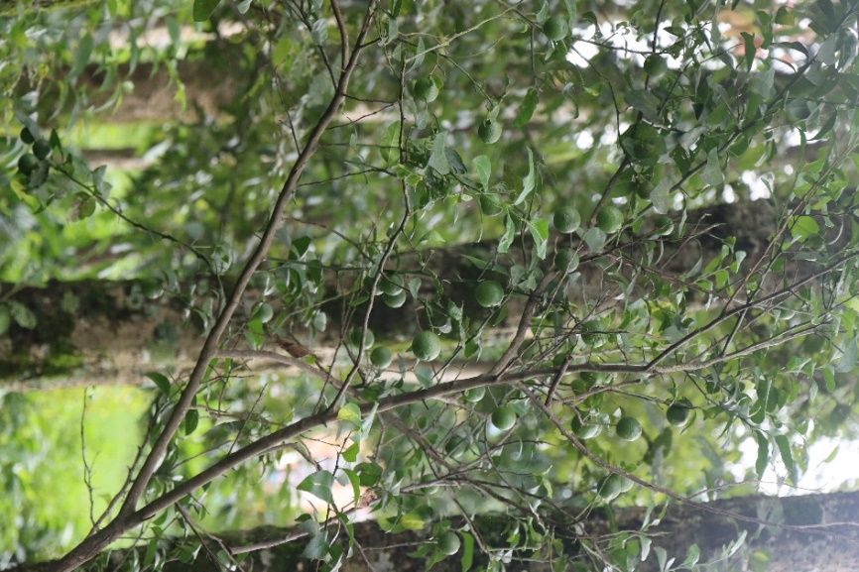

Adlay/Job’s tears

# Coix lacryma-jobi

Poaceae

Herb

The most distinctive feature of Job's tears is its seeds. These seeds are oval or tear-shaped, hard, and pearly-white, resembling polished beads. Similarly, the stems of Adlays are slender, erect, and reed-like, typically reaching heights of 60 to 120 centimeters. Moreover, its leaves are alternate and linear in shape, with a grass-like appearance. They can be up to 30 centimeters long and about 2.5 centimeters wide.

1. The hard and bead-like seeds of Job's tears are often used for making jewelry, accessories, and craft projects. The seeds are strung together to create necklaces, bracelets, and other decorative items.
2. In some cultures, Job's tears seeds are used as a food source. They can be ground into flour, cooked, and used in a variety of dishes, including porridge, soups, and desserts.

Its seeds have been used for thousands of years in traditional Chinese culture for their purported medicinal properties and symbolic significance. In Traditional Chinese Medicine (TCM), these seeds are known as "Yi Yi Ren" and are believed to have properties that can help with various health conditions, including arthritis and edema.

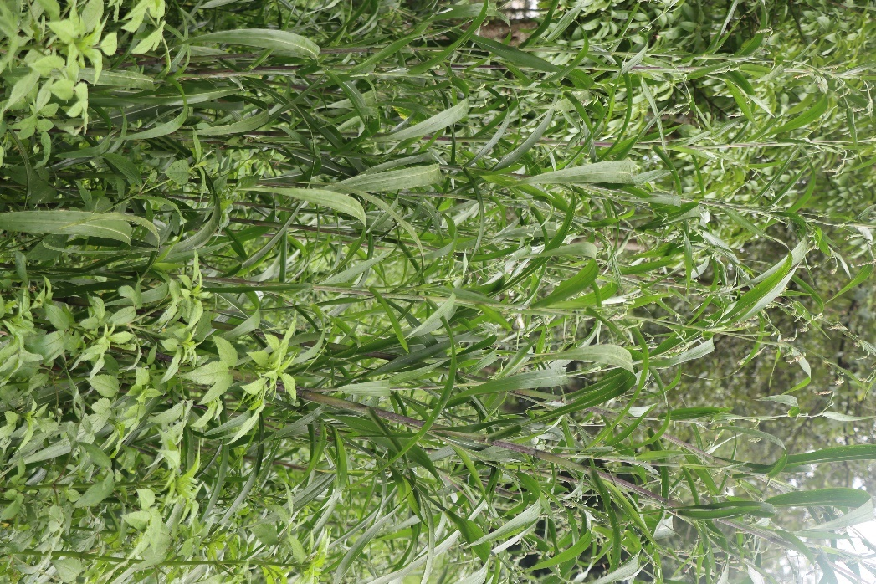

Ebolo/Thickhead

# Crassocephalum crepidioides

Anikale-jhar

Asteraceae

Herb

The leaves are one of the most prominent features of Crassocephalum crepidioides. They are thick, fleshy, and can be quite large, with a distinct dark green color. Similarly, the plant has a short, thick stem that emerges from the center of the rosette of leaves. The stem may be reddish or purplish in color. Moreover, it produces small, daisy-like flowers with white or yellow petals. The flowers are often found in clusters or inflorescences.

1. The leaves of Crassocephalum crepidioides are a good source of essential nutrients, including vitamins (such as vitamin A and vitamin C) and minerals. They are consumed as a leafy green vegetable in many African and Asian cuisines.
2. Crassocephalum crepidioides is sometimes used as fodder for livestock and as animal feed. It can be a valuable resource for supplementing the diets of farm animals.

A fun fact about Crassocephalum crepidioides is that it is often referred to by various colloquial names in different regions, reflecting its widespread cultivation and use. In addition to the common names "Ebolo" and "Thickhead," it goes by several other local names, such as "Cuban spinach" in some parts of the Caribbean and "Gardinia" in West Africa.

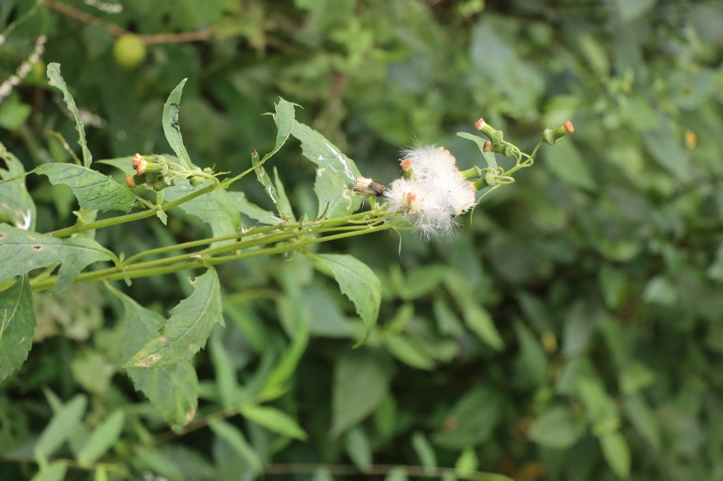

Dotted Smartweed

# Persicaria punctata

Polygonaceae

Herb

Smartweed typically has erect or ascending stems that can reach heights between 30 to 120 cm. The leaves are sword shaped and often have a distinct reddish or purplish spot in the center, giving the plant its "dotted" appearance. The size and shape of the leaves can vary, but they are generally pointed at the tip. Similarly, the flowers are arranged in elongated clusters called spikes. These spikes can be cylindrical or tapering and are often densely packed with tiny flowers. The flowers can vary in color, including shades of pink or white.

1. Dotted Smartweed is mainly used for its ornamental purpose.

This plant’s name "smartweed" is derived from the plant's acrid taste. When animals graze on it, they may exhibit signs of discomfort or "smarten up," avoiding further consumption due to the pungent taste. This characteristic has led to the common name "smartweed," reflecting the plant's ability to deter herbivores through its distinctive flavor.

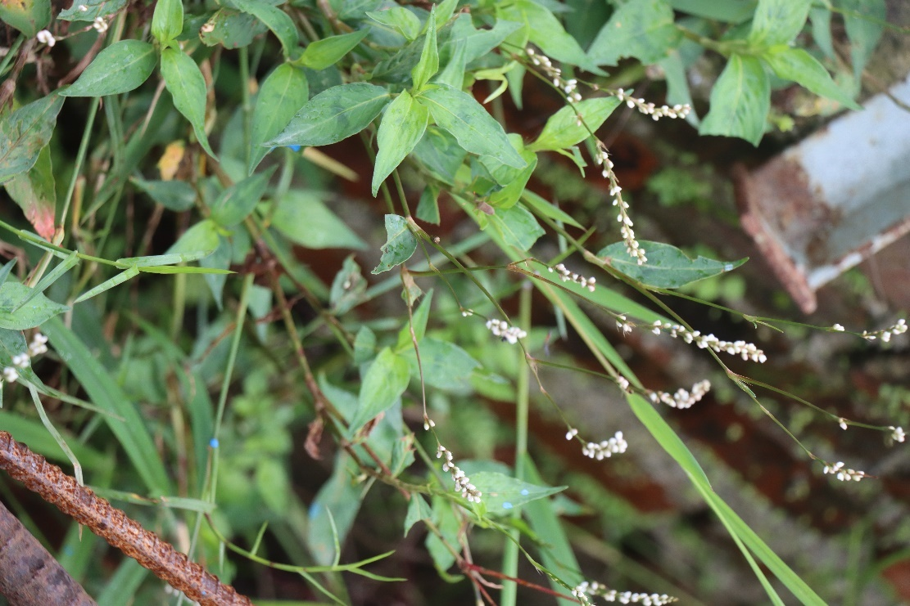

Indian Goosegrass

# Eleusine indica

Kodo Ghaas

Poaceae

Herb

The height of goosegrass can vary, but it typically grows close to the ground, reaching a height of 10 to 60 centimeters. The stems are flattened, spreading, and can root at the nodes, allowing the plant to spread horizontally. The stems may have a slightly reddish or purplish tint. Similarly, the leaves are linear, smooth, and may have a slightly rough texture. They are arranged alternately along the stems and the leaf blades are often folded.

1. Goosegrass, with its low-growing and mat-forming habit, can help control soil erosion in disturbed areas.
2. In some regions, goosegrass is grazed by livestock as forage. While it may not be a primary forage choice, animals may consume it when other options are limited.

The low-growing habit of goosegrass allows it to escape the blades of a lawnmower, and it can continue to thrive even in well-maintained lawns. This resilience and adaptability contribute to its status as a common and persistent weed in turfgrass areas, sometimes frustrating gardeners and lawn care enthusiasts who find it challenging to control.

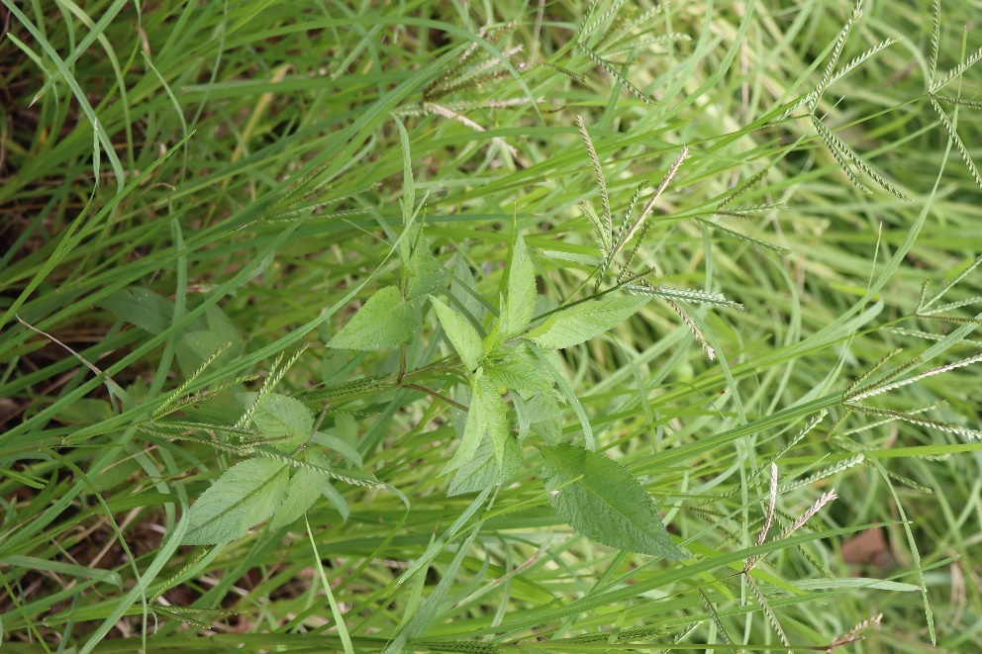

Elephant ear tree

# Ficus auriculata

Moraceae

Tree

Ficus auriculata grows as a medium-sized tree, reaching heights of 15 to 20 meters. The leaves of Ficus auriculata are large, glossy, and heart-shaped, resembling elephant ears, which gives the tree its common name. The leaves have prominent veins and can grow up to 15 centimeters in length. Similarly, the figs produced by Ficus auriculata are small and reddish to purple when ripe. They are usually borne in clusters on short stems and have a sweet flavor. Likewise, the bark of the tree is smooth and may be gray or brown in color. As the tree matures, the bark may develop fissures and become rougher.

1. Ficus auriculata is often planted for its ornamental value in gardens, parks, and urban areas. The large, glossy leaves and spreading crown make it an attractive shade tree.
2. The wood of fig trees is sometimes used in woodcraft, although Ficus auriculata is not a major timber species. It may be utilized for small-scale woodworking or local crafts.

The flowers of Ficus auriculata are actually hidden inside the figs. Female fig wasps enter the fig through a tiny opening called the ostiole to lay their eggs. As they do so, they inadvertently pollinate the flowers. The wasps eventually die inside the fig, and the fertilized eggs develop into wasps. The mature wasps then emerge from the fig, carrying pollen with them, and seek out new figs to repeat the process.

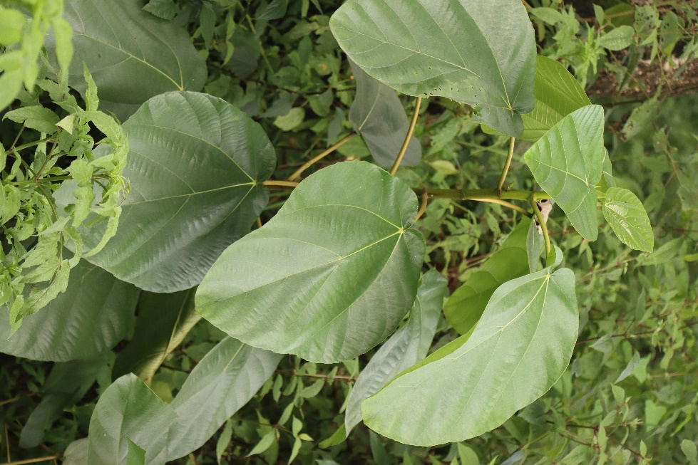

Spiked Ginger Lily

# Hedychium spicatum

Seto Saro

Zingiberaceae

Herb

Hedychium spicatum grows from thick, fleshy rhizomes, which are underground stems. These rhizomes give rise to new shoots and contribute to the plant's spreading growth habit. The plant produces tall, erect stems that can reach heights of 1 to 2 meters or more. The stems are typically unbranched and bear the leaves and flower spikes. Similarly, the leaves of Hedychium spicatum are large, lance-shaped, and arranged in an alternate fashion along the stems. They have prominent veins and can be up to 30 centimeters.

1. Hedychium spicatum is cultivated for its attractive and fragrant flowers, making it a popular choice in gardens and landscapes. The tall stems with dense spikes of white or cream-colored flowers add beauty and visual interest.
2. The dense growth and spreading habit of the plant contribute to soil stabilization, making it useful in certain landscaping situations, particularly in areas prone to erosion.

Hedychium spicatum is sometimes referred to as "Kapur Kachri." The name "Kapur Kachri" is derived from the Hindi words "Kapur," meaning camphor, and "Kachri," referring to a type of wild cucumber. This name reflects the plant's association with a pleasant fragrance reminiscent of camphor, which adds to its aromatic appeal. The combination of its delightful scent and the unique name "Kapur Kachri" adds a touch of intriue to this Himalayan native plant.

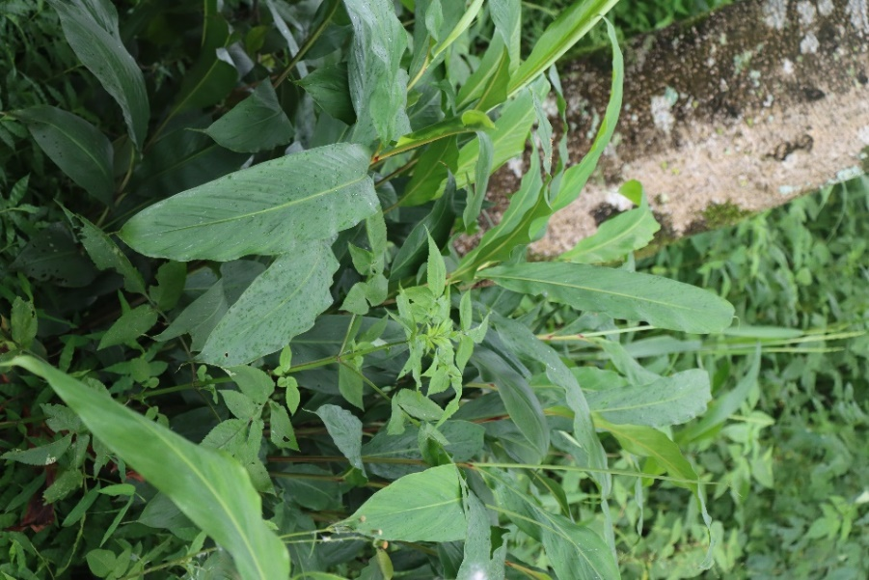

Date-plum

# Diospyros lotus

Ebenaceae

Tree

Diospyros lotus is a medium-sized tree that can reach heights of 10 to 15 meters. The leaves are typically elliptical or ovate in shape, alternate and have a smooth texture. Similarly, the fruit of Diospyros lotus is round or slightly oval in shape. When ripe, the fruit has a reddish-brown to orange color. The pulp of the fruit is sweet and edible, and it may have a taste reminiscent of dates.

1. The fruits are sweet and have a taste that is a blend of dates and plums. They are consumed fresh or can be dried for preservation
2. Date-plum fruits can be used in various culinary applications. They can be eaten raw, added to salads, or used in desserts and jams.
3. The wood of the date-plum tree is hard and durable. It has been used for crafting furniture, tools, and other wooden items.

The date plum is believed to have been one of the fruits traded along the ancient Silk Road, the network of trade routes connecting the East and West. The Silk Road facilitated the exchange of goods, ideas, and cultures between different civilizations. The date plum's journey along the Silk Road highlights its historical significance as a valuable and sought-after commodity in the trade routes that connected Asia, the Middle East, and Europe.

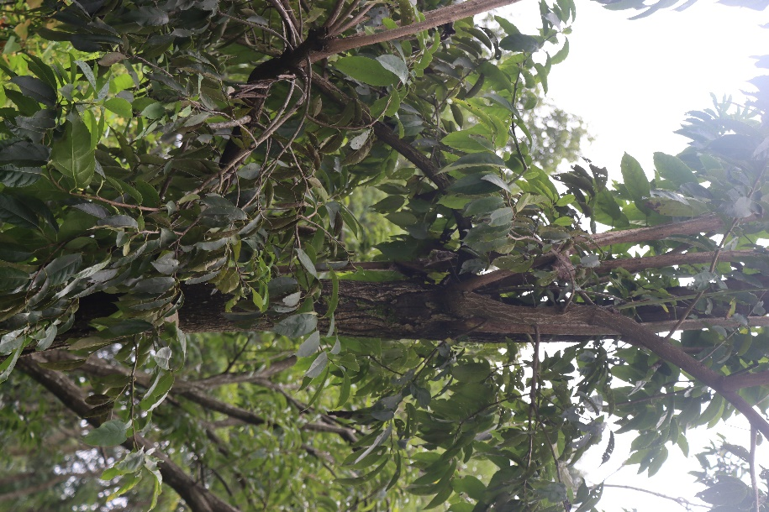

Horseweed

# Erigeron canadensis

Asteraceae

Herb

Horseweed can vary in height, ranging from a few inches to over six feet. The stems are typically erect, simple or branched, and covered with fine hairs. The stem may become woody at the base in older plants. Similarly, the small, inconspicuous flowers are arranged in panicles at the tips of the stems. Each flower head has both disk and ray florets. The color of the flowers can range from white to greenish-yellow. Likewise, the leaves are alternate, lance-shaped, and may have toothed or smooth margins. They are generally covered with fine hairs, giving them a slightly grayish-green appearance.

1. Due to its ability to establish quickly and produce a dense cover, horseweed can play a role in controlling erosion on disturbed soils.

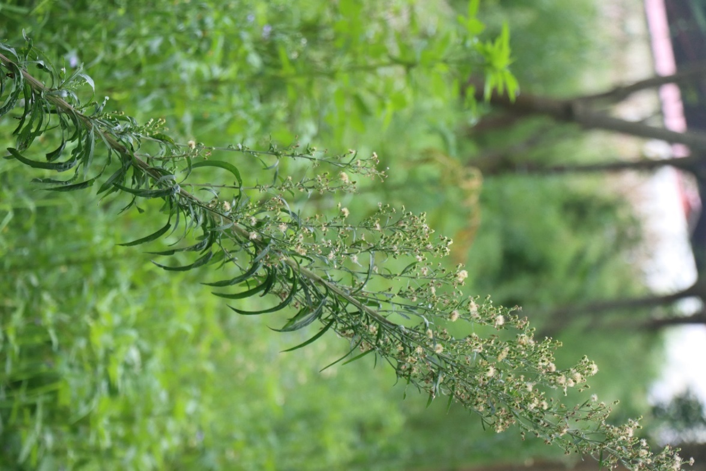

Taro

# Colocasia esculenta

Karkalo

Araceae

Herb

The height of the entire plant, including leaves and stems, can vary, but it generally ranges from about 60 to 120 centimeters. The leaves of Colocasia esculenta are large, heart-shaped, and typically peltate, meaning the petiole (leaf stalk) is attached to the center of the leaf. Similarly, Taro plants grow from an underground storage organ called a corm. The corm is swollen and starchy, serving as the primary organ for nutrient storage and reproduction.

1. The starchy corms of taro are a staple food in many tropical and subtropical regions. They are used in a variety of culinary dishes after being cooked. Taro corms can be boiled, steamed, fried, or roasted and are used in soups, stews, curries, and other traditional recipes.
2. Taro is a good source of complex carbohydrates and dietary fiber. It contains various vitamins and minerals, including vitamin A, vitamin C, vitamin B6, potassium, and iron.

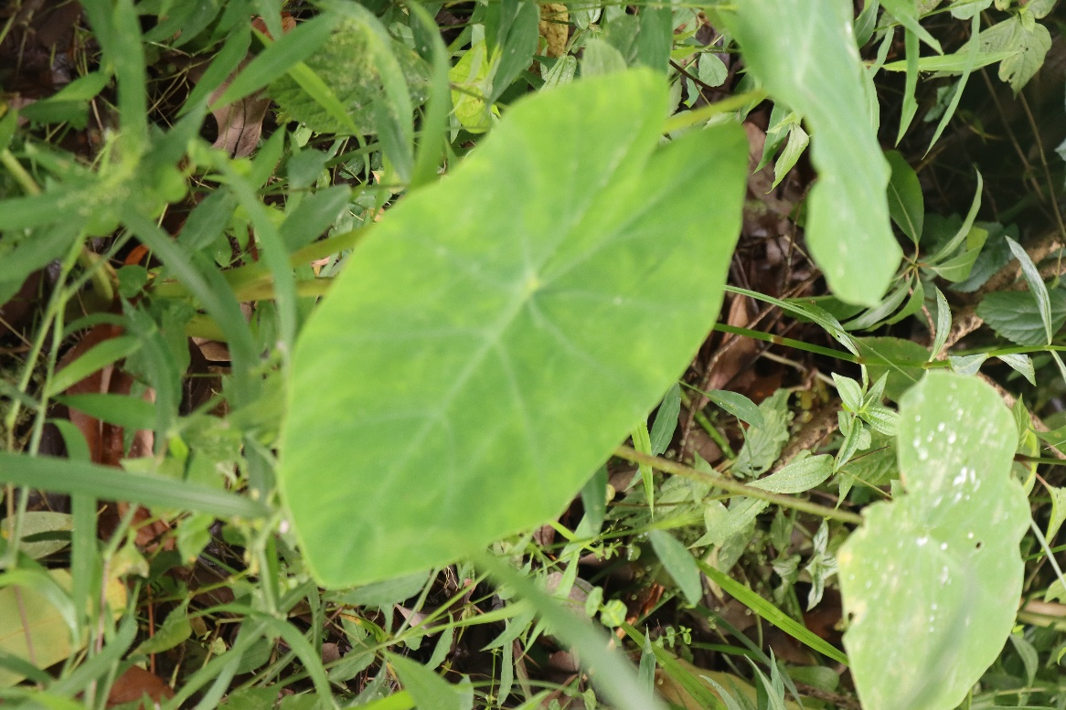

Echeveria

# Echeveria

Echeveria

Crassulaceae

Succulent plant

Echeverias typically grow in a rosette shape, where the leaves form a tight circular arrangement. The rosettes can vary in size, depending on the species and variety. The leaves of it are succulent and fleshy, storing water to survive in arid conditions. The leaves often have a waxy or powdery coating, which gives them a unique texture. Its leaves come in various colors, including shades of green, blue, purple, pink, and red.

1. Echeverias are popular choices for ornamental plantings in gardens, landscapes, and containers. Their attractive rosette shapes and vibrant colors add beauty and interest to indoor and outdoor spaces.
2. Due to their compact size and visually appealing features, Echeverias are commonly used in container gardens.

Some species of Echeveria are known for their ability to change color in response to environmental conditions, particularly sunlight. The intensity and hue of the colors in their leaves can vary based on factors such as light exposure, temperature, and the stress level of the plant. Under optimal growing conditions with plenty of sunlight, Echeverias often display vibrant and vivid colors. However, when exposed to stressors like intense sunlight or cooler temperatures, some Echeverias can undergo changes in coloration.

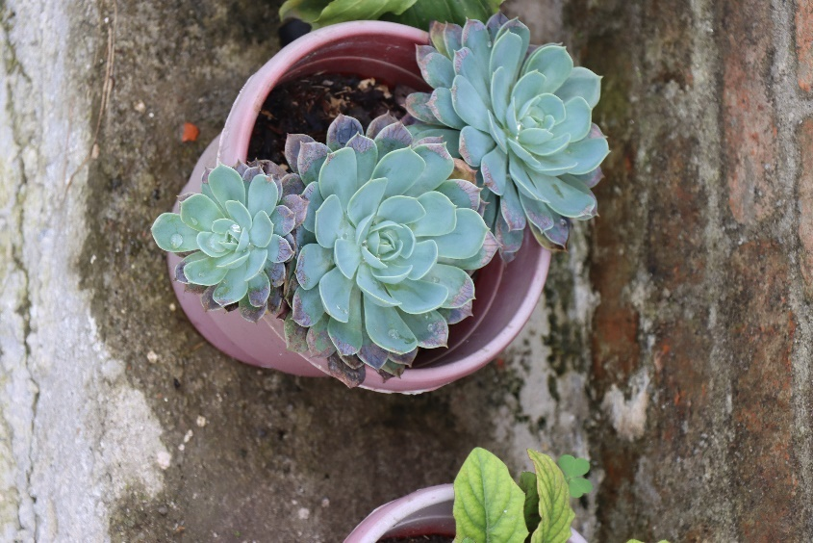

Balsam

Impatiens balsamina

Tiuri

Balsaminaceae

Shrub

Garden balsam plants typically grow to a height of 20 to 75 centimeters. The leaves are simple, serrated (toothed), and arranged alternately along the stem. They are usually lance-shaped and can be 5-10 cm long. The flowers are solitary and can be single or double, depending on the variety. The colors of the flowers vary and can include shades of pink, red, purple, and white.

1. Garden Balsam plants are very popular ornamental plants. The plant's vibrant and colorful flowers, as well as its lush foliage, make it a popular choice for gardens, borders, and floral arrangements.
2. Garden balsam is often used in landscaping to add a splash of color and visual interest to outdoor spaces.

The plant has seed capsules that, when mature, can explode when touched. This mechanism is sometimes referred to as "explosive dehiscence." When the capsules burst open, they release the seeds, which can be scattered several feet away from the parent plant.

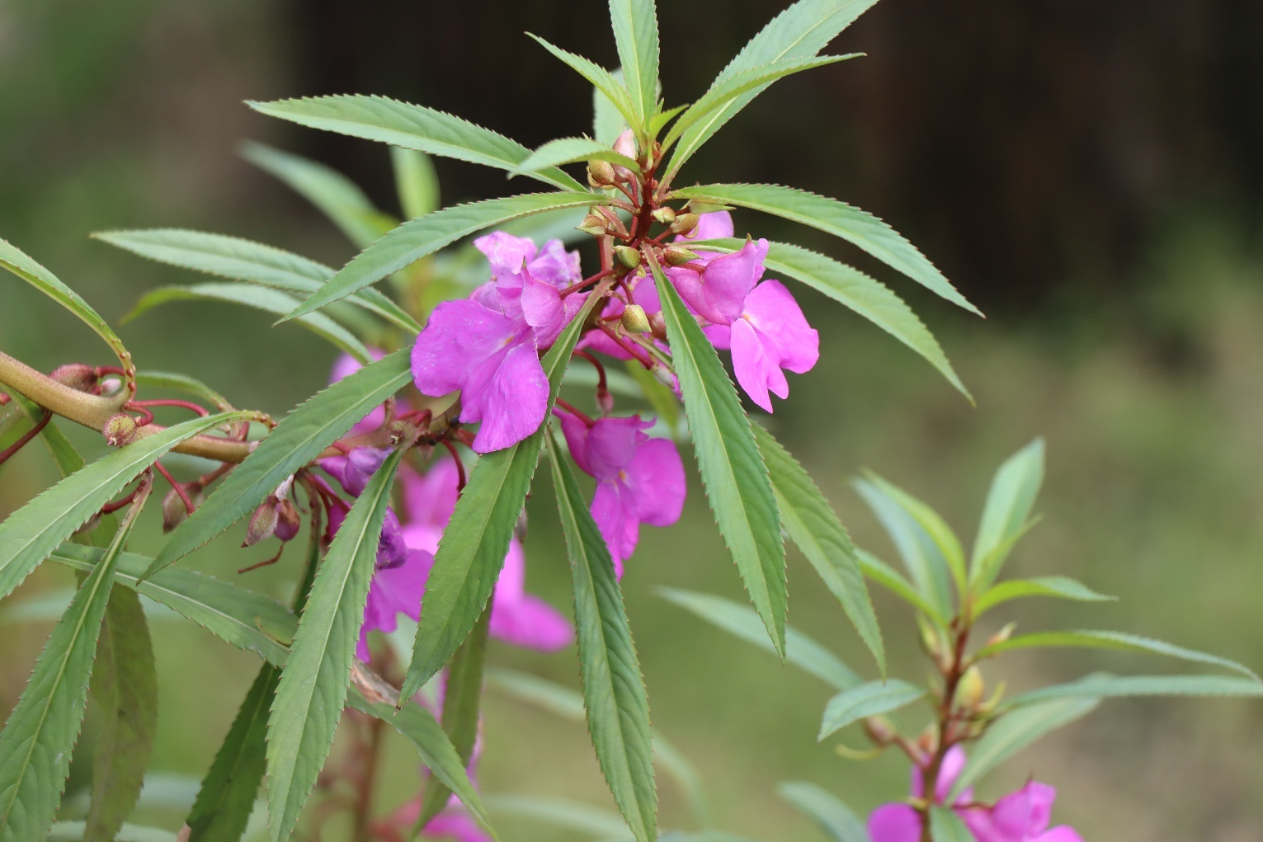

Cock Flower

# elosia argentea var. cristata

Bhale Phool

Amaranthaceae

Herb

Depending on the variety, cockscomb plants can range in height from about 30 to 90 centimeters. These plants have sturdy, erect stems that support the large flower heads. The stems are typically not woody, as it is an herbaceous plant. The flower heads of this plant are large, dense, and have a distinctive crested or comb-like appearance, resembling the comb of a rooster. The color of the flower heads can vary and includes shades of red, orange, pink, and sometimes yellow. The leaves of the cockscomb plant are typically simple, lance-shaped, and arranged alternately along the stems.

1. . Its unique and eye-catching flower heads, with their crested appearance, make it a popular choice in gardens, landscapes, and floral arrangements. The plant adds vibrant color and an interesting texture to flower beds, borders, and container gardens.

The unique flower heads of this plant have earned it various colorful and imaginative nicknames. In addition to being commonly referred to as "cockscomb" due to the resemblance of its flowers to a rooster's comb, the plant is sometimes affectionately called "brain flower" or "wool flower" because of the brain-like or velvety appearance of its crested blooms.

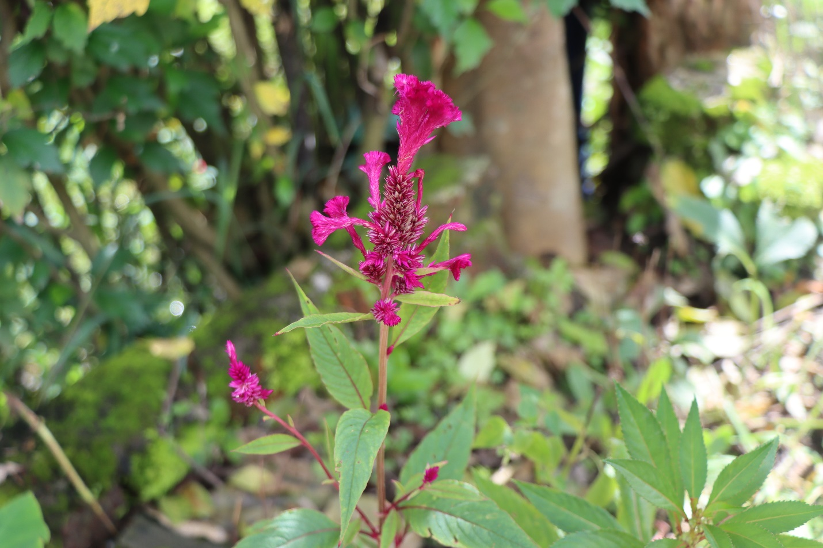

Globe Amaranth

# Gomphrena globose

Makhamali Phool

Amaranthaceae

Herb

The flowers of Globe Amaranth are arranged in dense, globe-shaped clusters that can be up to 1 inch in diameter. The individual flowers are tiny and papery, and they come in various colors, including shades of purple, pink, red, and white. The height of these plants can vary, but they generally range from 1 to 2 feet tall. Its leaves are simple, opposite, and lance-shaped. They are typically dark green in color and have a slightly rough texture.

1. The unique, globe-shaped flower heads and bright, long-lasting blooms of this plant make it a popular choice in gardens, landscapes, and floral arrangements. It adds vibrant colors and a distinctive texture to flower beds, borders, and container gardens.

The colored flower heads of Globe Amaranth are not actually true flowers but rather bracts—the specialized leaves that surround the actual, tiny flowers. The bracts are what give the plant its distinctive appearance and vibrant hues. This characteristic makes globe amaranth a visually interesting plant and contributes to its popularity in gardens and floral arrangements.

